**GROUP ASSIGNMENT**

**CT046-3-2-SDM**

**SYSTEM DEVELOPMENT METHODS**

**INTAKE CODE: APD2F2309CS(CYB)**

**HAND OUT DATE: WEEK 3**

**HAND IN DATE: 29 DECEMBER 2023**

**LECTURER: Mr. SIWA KUMARAN**

**CASE STUDY: HOME ASSIST – HOME MANAGEMENT SYSTEM**

|  |  |
| --- | --- |
| **Name** | **TP Number** |
| ABDULRAHMAN GAMIL MOHAMMED AHMED | TP071012 |
| IBRAHEEM MOHAMMED IMADELDIN AWAD | TP070765 |
| AMANULLAH GHAURI | TP071215 |
| ABDULELAH HUSSEIN ABDULRAHMAN AL-KAF | TP069319 |
| YAZEN ABOBAKR AHMED AL-MEHDHAR | TP069210 |
| ABDUL SHAFEY KHAN | TP071166 |
| MUHAMAD AHMAD AL MUHDAR | TP070208 |

TABLE OF CONTENT

1.0 INTRODUCTION 4

1.2 PROBLEM STATEMENT. 6

1.2.1- Problem 1: 6

1.2.2- Problem 2: 8

1.2.3- Problem 3: 10

1.2.4- Problem 4: 12

1.2.5 - Problem 5: 13

1.3 SUGGESTED SYSTEM. 14

1.4 Scopes and Objectives. 17

Scopes: 17

Objectives: 18

2.0 Agile Principles and IS Methodologies (Individual task). 20

2.1 Agile Principles. 20

2.1.1 Two principles of agile methodologies (Abdulrahman Gamil Mohammed Ahmed TP071012). 20

2.1.2 Two principles of agile methodologies (Yazen Abobakr Ahmed Al mehdhar TP069210). 21

2.1.3 (ABDULELAH HUSSEIN ABDULRAHMAN AL-KAF). 22

2.1.4 The 10th and 12th Agile principles (Ibraheem Mohammed Imadeldin Awad – TP070765). 23

2.1.5 Implementing Agile Principles (1st & 5th) (Abdul Shafey Khan-TP071166) 24

2.1.6 Agile Principles 4 & 7 (Amanullah Ghauri-TP071215) 25

2.1.7 Agile Principles 2 & 11 (Muhamad Ahmad Al Muhdar TP070208) 26

2.2 IS Methodologies. 28

2.2.1 Extreme Programming (XP) (Abdulrahman Gamil Mohammed Ahmed TP071012) 28

2.2.2 SCRUM (Yazen abobakr ahmed almehdhar) 32

2.2.3 Rapid Application Development (RAD) (IBRAHEEM MOHAMMED IMADELDIN AWAD TP070765) 35

2.2.4 SOFT SYSTEM METHODOLOGY (ABDULELAH HUSSEIN ABDULRAHMAN AL-KAF TP069319) 39

2.2.5 Rational Unified Process (RUP) (Abdul Shafey Khan - TP071166) 42

2.2.6 V-Model (Amanullah Ghauri -TP071215) 46

2.2.7 Design Thinking (Muhamad Ahmad Al Muhdar -TP070208) 49

3.0 SYSTEM ANALYSIS 53

3.1 Business Intelligence Analysis. 53

3.2 SWOT Analysis. 55

4.0 SYSTEM DESIGN. (INDIVIDUAL) 56

4.1 Data Flow Diagram (DFD) level 0 (Abdulrahman Gamil Mohammed Ahmed TP071012) 56

4.2 Use Case Diagram (Yazen abobakr ahmed almehdhar - TP069210) 58

4.3 Class Diagram (Ibraheem Mohammed Imadeldin Awad TP070765) 59

4.4 Entity Relationship Diagram (Abdul Shafey Khan-TP071166) 61

4.5 Sequence Diagram (Amanullah Ghauri – TP071215) 63

4.6 State Machine Diagram (ABDULELAH HUSSEIN ABDULRAHMAN AL-KAF – TP069319) 65

4.7 Activity Diagram (Muhamad Ahmad Al Muhdar – TP070208) 67

5.0 IMPLEMENTATION AND DEPLOYMENT. 69

5.1 Construction 69

5.2 Proof of Concept 70

Cleaners Booking: 71

Payment Processing: 71

Viewing Reviews: 72

Viewing Payment Sheet : 73

5.3 TESTING 73

5.4 System Deployment 80

5.4.1 Direct Cutover. 80

5.4.2 Phased Operation. 82

5.4.3 Best Change-over Method for Home Assist. 83

CONCLUSION 84

WORKLOAD MATRIX 85

REFERENCES 85

LOGIN

Figure 1:Context Diagram for early system 6

Figure 2: Context Diagram with solutions 16

Figure 3: Extreme programming 27

Figure 4: XP Methodology 28

Figure 5: XP Values 29

Figure 6: XP Feeback Loops 30

Figure 7: Scrum (Kukhnavets, P). 32

Figure 8: RAD Methodology Steps (WaveMaker, 2023) 34

Figure 9,(Mulder, 2022) 38

Figure 10: Stages of RUF (Ben Janse, 2023) 42

Figure 11: data flow diagram (DFD) level 0 53

Figure 12: Use Case Diagram 54

Figure 13: Class Diagram based on RAD. 56

Figure 14: An Illustration of Home Assist’s Operations via ERD Diagram 57

Figure 15: A sequence diagram for the service request functionality. 59

[Figure 16: State Machine Diagram based on SSM. 61](https://cloudmails.sharepoint.com/sites/SDMgroupassignment988/Shared%20Documents/General/SDM%20assignment.docx#_Toc154789745)

Figure 17: login 63

Figure 18: Reviews 63

Figure 19: Booking 64

Figure 20: Payment Processing 64

Figure 21: Payment successful page 65

Figure 22: prints all the reviews based on customer ID. 65

[Figure 23: Payment Sheet 66](https://cloudmails.sharepoint.com/sites/SDMgroupassignment988/Shared%20Documents/General/SDM%20assignment.docx#_Toc154789752)

Figure : Direct Cutover (Auliyaa, 2021). 73

Figure : Phased Operation (Auliyaa, 2021). 75

# 1.0 INTRODUCTION

Home Assist is a well-known operator in the home service industry with a long history and a solid organizational structure. With branches strategically placed across important regions, Home Assist has a national presence and serves a broad range of clients.

Furthermore, Home Assist takes great satisfaction in having a committed staff. Two seasoned managers lead the group, supervising and arranging several facets of the business's activities. Three skilled clerks assist the management group and help ensure that administrative procedures run smoothly. The frontline staff of Home Assist is made up of experienced cleaners and service providers who make sure the company offers its clients high-quality services.

The wide range of property owners seeking dependable and superior home services is reflected in the company's clientele. Home Assist has established a reputation for meeting a wide range of customer demands, whether they are from home consumers in need of regular cleaning or business organizations in need of specialised maintenance.

Home Assist manages services using a manual, conventional method. The processing of customer requests via phone calls or in-person queries sometimes creates difficulties for scheduling and monitoring service times. Vendor collaborations also need manual verifications via an extensive paper-based procedure. Although effective, the current system offers room for enhancement and efficiency advantages with the introduction of a full-featured Home Service Management System.

The goal of the proposed Home Service Management System is to completely transform Home Assist's operational procedures. The organization may improve vendor-customer relations and expand its service offerings by giving suppliers the ability to register and undertake required verifications. Customers will gain from an easy-to-use system that enables them to effortlessly request services, get invoices, and make payments. To maximize business productivity, the proposed system would also provide Home Assist's management with access to tools for more organized scheduling, payroll processing, and thorough reporting. With a four-month timetable and an RM 60,000 budget, this initiative paves the way for Home Assist to adopt cutting-edge technology and improve the caliber of its services.

**Context Diagram:**

Figure 1:Context Diagram for early system

## 

## 1.2 PROBLEM STATEMENT.

### 1.2.1- Problem 1:

|  |  |
| --- | --- |
| No auto-generating calculations for vendors and workers. | Problem title: |
| As is clear from the case study offered, the HOME ASSIST organization needs exact calculations that are advantageous to all parties involved. To calculate accurate vendor partnerships, dedicated servers must be set up by the firm responsible for automating the organization's processes. This makes sure that partnership ratios are distributed fairly and equally. Additionally, we intend to implement a bonus structure for employees, with a 10% bonus cap on prospective bonuses based on client feedback. this will inspire employees to pursue excellence and boost their performance by implementing this functionality. | Description: |
| * Human Error: Many issues arise due to mistakes made by individuals. These errors can include data entry, miscommunication, or a failure to adhere to procedures. * Technical Challenges: Problems may also emerge from difficulties like software glitches, hardware malfunctions or network disruptions. * Misunderstandings: Occasionally problems occur because of misunderstandings or misinterpretations. These misunderstandings can arise in communication, requirements, or expectations. * Process Breakdowns: Problems can occur when established processes fail. If a process is poorly defined, not followed correctly or inefficiently designed it can lead to issues. * External Influences: External factors such as changes in regulations economic conditions or market trends can also pose challenges, for an organization. | Source/Cause: |
| It improves calculation efficiency and spares administrators the time-consuming process of performing manual calculations, making all business-related calculations simple and straightforward Additionally, by implementing these elements, the business will improve its reputation and build trust with all its stakeholders, including clients, suppliers, and staff. This fair strategy encourages people who want to work with this prestigious organization to engage with vendors. | Effect: |

### 1.2.2- Problem 2:

**2. Delayed or Inefficient Payment Processing**

|  |
| --- |
| **Description:**  Payments are essential for Home Assist's operations. However, the current system struggles with processing these promptly. Customers today expect quick services, and delays can lead to doubts about Home Assist's reliability. These hold-ups not only affect customer trust but can also disrupt the company's financial management. Such challenges hinder Home Assist's aim to stand out in the home services market. |
| **Cause:**  Manual Payment System: Home Assist relies on manual methods for handling payments, which lacks the efficiency and speed of modern automated systems. This can slow down transaction times and make the overall system less reliable.  Verification Delays: With each transaction requiring manual verification, there's an inherent delay in confirming payments. This approach can lead to a pile-up of unprocessed payments, particularly when there's a high demand for services.  Potential for Mistakes: Given the manual nature of the process, human errors are highly possible. Mistakes could range from incorrect data entry to oversight, affecting the accuracy of payment records.  Outdated Methods: In today's fast-paced digital era where many companies have adopted instant payment systems, Home Assist's traditional manual approach may seem out of touch and less appealing to customers.  Increased Staff Workload: Without automation, the staff is burdened with additional responsibilities. This not only affects their productivity but also can lead to burnout or oversights due to the repetitive nature of manual tasks.  Inconsistencies: The reliance on manual entries and confirmations can lead to inconsistencies in payment records. These inconsistencies can result in disputes or dissatisfaction among both customers and service providers. |
| **Effect:**  Longer Wait Times: Customers experience extended waits for service confirmations, leading to increased dissatisfaction. This prolonged process can test customer patience and ruin the first-time user experience.  Lost Business: Delays might discourage loyal customers or drive them to search for faster alternatives with competitors. As wait times extend, the likelihood increases that customers will opt for other options.  Revenue Impact: Home Assist is at risk of financial setbacks due to unhappy customers and inconsistencies in payments. Any delay or error can translate to missed financial opportunities and undermine profitability.  Operational Challenges: The dependence on a manual payment system intensifies the workload for the administrative staff and increases the likelihood of mistakes. This added burden not only consumes more time and resources but can also impact the overall enthusiasm and productivity of the team.  Company Reputation: The cumulative effects of these issues can damage the company's growth and ruin its market reputation. In the long run, this could challenge Home Assist's position in the competitive home services market. |

### 1.2.3- Problem 3:

|  |  |
| --- | --- |
| Problem title: | **Inadequate Customer Review Management** |
| Description: | Home Assist faces a substantial challenge in effectively handling customer feedback, which is essential for their growth and reputation. The business does not presently have a formal structure in place to formally gather, monitor, and respond to customer feedback. As a result, customers' valuable feedback and suggestions—which might be essential for improving their services—frequently go unnoticed and unaddressed. |
| Cause: | The root cause of this issue is the lack of a well-defined method for collecting and organizing customer feedback. Without a well-defined procedure in place, Home Assist is unable to collect, organize, and evaluate customer input. Their ability to gather valuable data from customer feedback and then make the necessary changes is limited because of this issue. Major factors include:   * Lack of a dedicated method for collecting input. * Lack of a centralized platform and uniform feedback formats.   Inadequate staffing or resources allocated to handling consumer reviews. |
| Effect: | Building trust and a strong reputation in the service industry depends on receiving and using client feedback consistently. If this problem is not resolved, it may have several negative implications on Home Assist's services and client relationships:   * Customers may feel ignored and devalued, which lowers their satisfaction with Home Assist's services. * Customers may find it difficult to have faith in the quality of services offered if a business is not responsive to consumer feedback. * Home Assist may fail to recognise critical opportunities for service improvement in the absence of the capacity to extract insightful data.   In a competitive sector, businesses that respond intently to consumer input have a clear edge, whereas Home Assist runs the danger of slipping behind. |

### 1.2.4- Problem 4:

|  |  |
| --- | --- |
| **Lack of Performance Tracking** | Problem title: |
| The Home Assist stable does not have a system for monitoring the performance of cleaners or providing reports on payment sheets. Additionally, the company needs to improve the level of service that it provides to its customers. Therefore, the service will guarantee that it will assist to please the client's wants, and as a bonus, this feature will please the customer since it will show them an exact detail of the service that they are purchasing. | Description: |
| * **Lack of an accurate service:** which means that the client will not get an accurate description or information of the service that is being purchased. * **Limited data visibility:** the lack of capacity to monitor performance might put the firm at a disadvantage when compared to its competitors in terms of its ability to remain sustainable. * **Inadequate reporting tools:** The home assist system does not have the essential tools for it to create comprehensive service delivery for the client. The absence of this function could decrease confidence in the operation of the organization. | Source/Cause: |
| Because of this, Home Assist may have trouble recognizing and acknowledging outstanding performance among its cleaners, which might possibly lead to difficulty in meeting service quality requirements. In addition, there is a possibility that clients may not have a straightforward understand of the service that they are getting, which may influence the point at which they are satisfied. | Effect: |

### 1.2.5 - Problem 5:

|  |  |
| --- | --- |
| Inefficient Cleaner Scheduling. | Problem title: |
| The ineffective scheduling of cleaners for their services presents problems for Home Assist. Due to overlapping or delayed cleaning appointments, this inefficiency leads in suboptimal resource allocation and may cause customer discontent. A more efficient scheduling system that optimizes cleaner assignments based on job requirements and availability must be put in place to address this problem. | Description: |
| Operating ineffectively    The existing scheduling procedure makes extensive use of human input, which can lead to operational inefficiencies such as double reservations, inadequate information, and ignored scheduling requests.    Processes are not well-structured:    Lack of a clear scheduling process leads to misunderstandings and mistakes in cleaner assignments. To make sure cleaners are assigned to the right jobs, an organized strategy is required.    Technical restrictions:    The inability of current scheduling technologies to automate and optimize cleaner assignments may be a contributing factor to scheduling inefficiency. | Source/Cause: |
| Improved scheduling has a direct impact on client satisfaction since it permits prompt and coordinated cleaning services. Customers who are happy with the service are more likely to leave favorable reviews and come back again, which improves Home Assist's reputation and draws in more clients. Additionally, using an automated scheduling system reduces the possibility of scheduling mistakes and operational hitches, which helps make overall corporate operations run more smoothly. | Effect: |

## 1.3 SUGGESTED SYSTEM.

**1. Auto-generating of calculation system.**

**Proposed Solution:** To enhance the Home Assist environment of work we need to implement servers that will serve as the calculator man to perform all the calculations of the company, the Auto-Generating Calculation System is one of the key components of the proposed Home Assist Efficiency Improvement System. This system is designed to streamline and automate multiple computations to handle services, payments, vendor relationships, and employee bonuses accurately and effectively. The Auto-Generating Calculation System is an essential part of the Home Assist Efficiency Improvement System for guaranteeing the precision and effectiveness of calculations in a range of business-related domains. This automation not only saves time but also fosters greater fairness and trust among all stakeholders.

**2. Automated Payment Processing and Confirmation System.**

**Proposed Solution:** To enhance the efficiency and reliability of the Home Assist service management system, it's crucial to integrate a secure online payment gateway. This integration is not merely about digitizing transactions but aims to simplify the entire payment process for users. Automating payment confirmations ensures that customers receive timely acknowledgments of their transactions, eliminating uncertainties that manual systems often entail. Furthermore, by accelerating the service booking process, we not only enhance the user experience but also boost the efficiency of the system. With swift payment procedures, customers can seamlessly transition from selecting services to confirming bookings, making the overall process user-friendly.

**3. Software-Based Customer Review Management System.**

**Proposed Solution:** Home Assist can offer specialized software to handle the problem of insufficient customer review management. Making a user-friendly customer review platform inside the Home Assist software, accessible via their website, would be the first step. Structured feedback forms should be established inside this site. To make it simple for users to submit their opinions and experiences, these forms should have simple rating scales, checkboxes, and optional open-text areas. Furthermore, Home Assist may provide real-time alerts to promote prompt feedback reporting. Customers might get automated reminders asking for their input immediately after receiving a service.

**4. Automated performance tracking system.**

**Proposed Solution:** It is recommended that to solve this problem, a performance tracking system should be developed. This system should not only record the performance of the cleaners, but it should also automate the generation of payment sheets. In addition, the managers would be able to evaluate and reward the cleaners based on performance, which would result in an increase in the quality of service as well as an assurance that the customers would be satisfied according to the system's transparency and responsibility.

**5. Automated Cleaner Scheduling System.**

**Proposed Solution:** The goal of this system is to address the issue of ineffective cleaner scheduling and maximize the efficiency of cleaning employees. This system's key characteristics include arranging cleaners according to their skills, locations, and availability so that duties can be successfully assigned to them. A simple and well-defined scheduling procedure reduces misunderstandings and human mistakes, while real-time scheduling features stop conflicts and multiple bookings. Customers will have the option to indicate their desired cleaning schedules and needs, enabling a customized experience.

Figure 2: Context Diagram with solutions

## 1.4 Scopes and Objectives.

### Scopes:

1. put in place an automated bonus calculation mechanism for both employees and vendors, ensuring that it is just and accurate.

2. To ensure that financial transactions proceed smoothly and on schedule, we should improve the efficiency of the payment processing system.

3. How about developing a user platform that allows clients to provide comments with ease? Can we report on it right away?

4. To make things easier, we are going to create a system for tracking performance that creates payment sheets and automatically evaluates our cleaners.

5. To maximize our cleaners' assignments, minimize inefficiencies, and prevent timetable conflicts, we must implement an automated scheduling system.

6. Having an invoicing system that produces bills fast and effectively would be fantastic for our management.

7. By strengthening safeguards to secure both operational and customer data, we must place a high priority on data security and privacy.

8. We can obtain performance insights from consumer comments by incorporating a reporting and analytics module.

9. create a user interface that works with both web browsers and mobile devices to make sure that everyone can access our platform with ease.

10. To ensure that Home Assist employees can seamlessly adopt the new systems and make efficient use of them, we should also offer training and support to them.

### Objectives:

* + - 1. Improved Efficiency:

By incorporating automated methods Home Assist can enhance the effectiveness of its operations.

* + - 1. Customer Satisfaction:

Enhance customer satisfaction, by providing a user platform for feedback and ensuring response to consumer queries and service requests.

* + - 1. Operational Enhancement:

Enhance scheduling for cleaners to minimize conflicts and delays ensuring optimal resource utilization and a positive customer experience.

* + - 1. Business Administration:

management by automating invoicing processes reducing the chances of overdue payments and maintaining an efficient payment system.

* + - 1. Stakeholder Respect:

Foster transparency in procedures and implement fair and accurate calculations to in still confidence among stakeholders such as clients, suppliers, and employees.

* + - 1. Gain an Advantage:

Stand out in the industry by implementing innovative practices that position Home Assist as a customer-focused service provider.

* + - 1. Adaptability and Scalability:

Create systems that can adapt to changing business needs and grow alongside Home Assists expansion plans.

* + - 1. Regulatory Compliance:

Ensure compliance with laws and industry standards when adopting automated systems and managing data.

* + - 1. Employee Motivation:

Encourage excellence in performance by introducing an incentive structure based on customer feedback.

* + - 1. Continuous Improvement:

Strive for improvement through evaluation of processes seeking opportunities, for innovation, efficiency gains, or better customer experiences. Encourage a culture of improvement by evaluating and enhancing the implemented systems based on feedback and changing business needs.

**1.5 Gantt Chart**

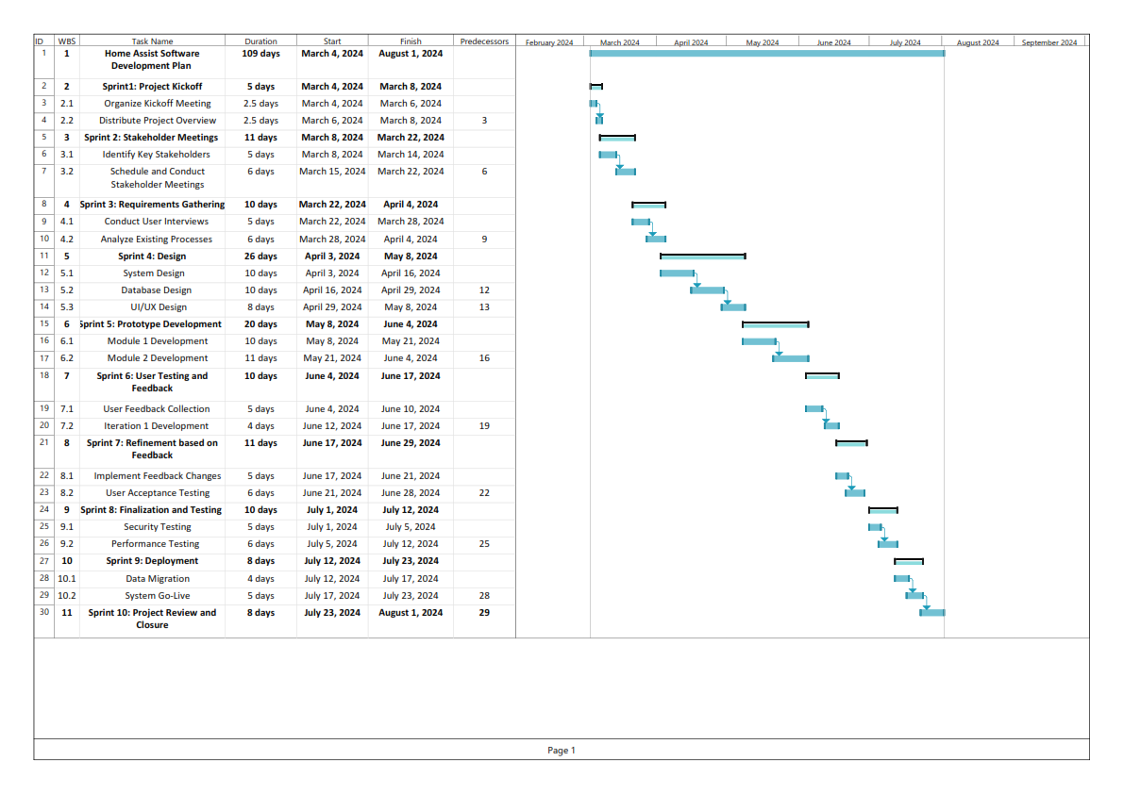

# 2.0 Agile Principles and IS Methodologies (Individual task).

## 2.1 Agile Principles.

### 2.1.1 Two principles of agile methodologies (Abdulrahman Gamil Mohammed Ahmed TP071012).

**1- Deliver Services on Time and Continually to Please Customers.**

1.1 Timely Provision of Services

Establish a system that guarantees on time and consistent service delivery. This objective can be accomplished by implementing the automated scheduling system outlined in your project plan. By optimizing the allocation of cleaners and ensuring service we adhere to this principle.

1.2 Continuous Enhancements

Deliver services, in stages allowing customers to witness improvements. This can be achieved by offering a service tracking mechanism that enables customers to monitor the progress of their service requests.

1.3 Prompt Customer Input

Promote customer feedback by providing a platform for sharing opinions and suggestions after the completion of a service. This feature can be seamlessly integrated into the customer review management system proposed in your project plan.

1.4 Embrace Adaptability

Enhance the flexibility of your service processes to promptly respond to evolving circumstances and customer preferences. By implementing the suggested Auto Generating Calculation System you'll be able to adjust pricing and services in accordance, with customer demand and market fluctuations.

**2. Face-to-face communication is the most effective method.**

2.1 Utilize Synchronous Communication

While it may not always be feasible to have face-to-face conversations, take advantage of technology to facilitate real time communication among team members. This can be achieved through video conferences, instant messaging tools and virtual meetings, for both teams and external collaborators.

2.2 Encourage Timely Issue Resolution

Promote the resolution of work-related problems by allowing team members to discuss issues without relying on email exchanges. Establish channels of communication where team members can address concerns and find solutions in time.

2.3 Promote clear communication by utilizing platforms to share project updates, status reports and important information. Make use of project management software that enables all team members to access project details and collaborate efficiently.

By incorporating these principles into the case study Home Assist can improve its service delivery respond to customer needs effectively and enhance communication among team members, customers, and external vendors. As a result, this will lead to increased customer satisfaction and overall business success (What Are the 12 Principles of Agile Project Management?, 2023).

### 2.1.2 Two principles of agile methodologies (Yazen Abobakr Ahmed Al mehdhar TP069210).

**3: Deliver Working Software Frequently**

Agile Principle 3 emphasizes the significance of consistently delivering functional software. By doing this, the development process of the home assistance system is divided into more manageable steps or sprints. For instance, the first sprint of development could include the delivery of essential functionality like customer registration and service request submission. Hold stakeholder demonstration sessions following each sprint to obtain input and make necessary modifications, promoting early user interaction and ensuring that the program satisfies user requirements. The second sprint could be service request submission, then vendor management, or cleaner scheduling. The incremental delivery of value to consumers is made possible by the iterative development strategy, which allows for ongoing product refinement and prioritization based on feedback and altering requirements.

**9: Strive for Technical Excellence and Good Design**

Agile Principle 9 highlights the importance of preserving high-quality code and system design across the course of a project. It's critical to set standards like regular code reviews among your development team to ensure code quality and detect potential issues if you want to effectively adopt this approach for Home Assist's Home Service Management System. Automated testing should be used to continuously verify software functioning and find bugs early in the development cycle. Spend time refactoring code as well to keep the codebase organized and effective while paying off technical debt. Finally, to ensure extensibility, maintainability, and scalability, think about including appropriate design patterns into the architecture of the system, such as the Model-View-Controller (MVC) pattern. This dedication to technical quality and sound design will support the software system's long-term viability and sustainability (Lowell, 2023).

### 2.1.3 (ABDULELAH HUSSEIN ABDULRAHMAN AL-KAF).

**5: Projects are built around motivated individuals, who should be trusted.**

The 5th iteration of the agile development methodology lays a strong focus not only on the work done by the team but also on the importance of trust. Effective team management involves providing your team with the autonomy and trust they require to outgrow. ‘Home Assist’ wants to interact with external suppliers, such as air-conditioner service providers and plumbers. To create trust in these relationships, the Home Assist owner should empower vendors by enabling them to register through the new system, identifying their service type and pricing. It is essential to develop a user-friendly interface to convince clients to place their trust in and make use of the Home Assist system. Customers can establish accounts without any difficulty, as well as request services and make payments. Yet, the system should also contain a straightforward and free return policy, which must indicate that the service request will be fulfilled if payment is paid within a specified amount of time after the first request. (Popiolek, 2019)

**8: Sustainable development, able to maintain a constant pace.**

It's essential to adhere to the 8th agile principle, which confirms the importance of maintaining a consistent and sustainable pace throughout the project's lifecycle. This principle suggests that the project should not start at full speed and attempt to maintain an unsustainable pace but should follow a more measured and enhanced approach. Home Assist's project to automate their home service management system should adopt a measured and sustainable approach in its development. Rather than rushing into full-scale implementation, they should start at a fast but sustainable pace. This approach ensures a steady and predictable level of work throughout the project's duration. For instance, when introducing the system to customers and vendors, Home Assist could begin by rolling out essential features and services first, such as user registration, service requests, and payment processing. They may test and improve these fundamental elements using this logical manner before slowly adding more complex features like the review system, coupon management, and thorough reporting. Home Assist can easily adjust to changing needs and priorities that could occur during the project by keeping this sustainable pace. For example, the team may make improvements without getting overloaded if client feedback indicates a need for more service kinds or improvements to the scheduling system.

### 2.1.4 The 10th and 12th Agile principles (Ibraheem Mohammed Imadeldin Awad – TP070765).

**10: Simplicity**

The 10th point of the agile principles emphasizes the ability to maximize the output while doing the least amount of work that is possible to produce a high-quality product which in this case is the new system with all the additional features that home assist requires. The use of tools such as CASE (Computer Assisted Software Engineering) tools to create the system as well as the implementation of pre-existing templates will help to cut down the amount of time needed to create the new and improved Home Assist system. Applying the simplicity concept into the system as well creates a system that can perform the same tasks more efficiently and effectively and since the production of system was done in a simple manner when problems arise, they can be dealt with swiftly as it will be easy to adjust the simple structure of the system.

**12: Regular Reflection and Adaptation**

The 12th agile principle focuses on the importance of learning from previous mistakes made by either an individual or a group to ensure the same mistake is not repeated and to improve the quality of the work. While developing a system such as what is required by Home Assist mistakes are bound to be made but what matters is learning from how those mistakes affected, delayed, or even halted the development process completely, how they were fixed and what kind of experience was gained form dealing with those mistakes. The principle also emphasizes adaptation and, in this case, adapting to the issues and changing customer requirements where at any point the customer decides to make changes to the final product the development team should not be hesitant in taking on the tasks and adapting to the requirements.

### 2.1.5 Implementing Agile Principles (1st & 5th) (Abdul Shafey Khan-TP071166)

**Principle #1: Customer Satisfaction through Early and Continuous Delivery of Valuable Software**

This Agile Principle highlights the importance of timely, useful software delivery in an incremental and iterative manner to guarantee customer satisfaction. To implement this principle, a sprint-based methodology can be implemented by the Home Assist project team. Every step of the project is broken down into smaller, more manageable sprints, with each sprint ending with the delivery of a working software component. For instance, the earliest sprints can concentrate on key features such as vendor and customer registration.

The supplied software component should gradually be available for internal testing and evaluation when each sprint is finished. Customers and other stakeholders should be encouraged to provide constructive criticism throughout these review periods. Such input maintains consistency with changing consumer demands and preferences and serves as a basis for incremental changes.

**Principle #5: Projects are Built Around Motivated Individuals, Who Should Be Trusted**

This Agile Principle emphasizes the role of motivation and trust in cultivating a positive work environment and the success of a project. To implement this principle. Home Assist must aim to provide team members with autonomy in everyday operations. The team leaders should provide each member with the freedom to take on their responsibilities. Software developers are also given the freedom to choose coding practices and tools if they do it within established parameters. This independence encourages a culture that values creativity and innovative solutions to problems.

When necessary, managers should actively assign tasks and decision-making power to team members. By encouraging cooperation and teamwork, this practice fosters an atmosphere where thoughts and views are respected. The success of the project depends on the team members developing a culture of mutual respect and trust.

### 2.1.6 Agile Principles 4 & 7 (Amanullah Ghauri-TP071215)

**Principle #4: Close, daily cooperation between businesspeople and developers.**

Agile principle four advocates for close collaboration between business professionals and developers daily. In the context of Home Assist, this principle ensures that product development is continuously aligned with customer needs and business goals. This will involve daily stand-up meetings to ensure constant communication, swift decision-making, and immediate feedback. To implement Agile principle four in the Home Assist project, we're setting up a workspace where ideas flow freely, and everyone can contribute. We'll map out a clear workflow that mirrors our business aims, making sure every step-in development serves our end goals. This setup is designed to be adaptable, letting us quickly adjust to new insights or challenges, ensuring our team can pivot without losing pace, all while keeping our focus on creating a service that fits our users' lives.

**Principle #7: Working software is the principal measure of progress.**

Agile principle seven emphasizes that the true indicator of progress is a working software. In the context of Home Assist, this principle underlines the importance of having a functional prototype early in the process that can handle core business functions like scheduling, payments, and generating business reports. Progress is measured by the functionality that the software provides rather than the completion of project phases or volumes of documentation. For the implementation, we will adopt a continuous delivery approach, where we release a basic version of the software early and improve it iteratively based on user feedback. This could mean starting with the most critical functions, such as service scheduling and payment processing. As soon as these core features work reliably, we can consider them as progress and build upon them.

### 2.1.7 Agile Principles 2 & 11 (Muhamad Ahmad Al Muhdar TP070208)

2- Welcome Changing Requirements, Even in Late Development:

Application to Home Assist:

- Home Assist can offer its services in stages. Rather than attempting to enhance every facet simultaneously, the organization may concentrate on a single facet, like customer service, and implement gradual and impactful enhancements contingent on evolving client requirements.

- To get feedback on the services offered, regular customer and staff feedback meetings could be held. This enables Home Assist to modify its products in response to immediate input, even when it is received towards the end of the development process.

For example, Home Assist can immediately adapt its service offers if clients indicate a need for more services, such as emergency support.

2. Best Architectures, Requirements, and Designs Emerge from Self-Organizing Teams:

Application for Home Assist:

- Administrators, cleaners, and outside vendors can build cross-functional teams with Home Assist. Teams can now manage a variety of duties without depending on several departments thanks to this. Innovative ideas may develop in these teams when open communication is encouraged. For instance, the cleaning crew may recommend changes to the scheduling procedure that would boost productivity.

- Giving teams the freedom to choose how they want to do their tasks encourages a sense of ownership and responsibility. If the cleaning crew finds a better way to organise materials, they can make the adjustment without waiting for management's approval.

Continuous Improvement: One way to adopt a continuous improvement mindset is to regularly analyze and enhance the manual procedures that are in place for payroll, vendor engagement, and customer evaluations. To do this, the team must evaluate what is currently working well and what may be improved.

- Providing employees with training chances to improve their abilities helps teams become more self-organizing. For example, giving administrators IT training can enable them to automate routine duties and improve workflows.

## 2.2 IS Methodologies.

### 2.2.1 Extreme Programming (XP) (Abdulrahman Gamil Mohammed Ahmed TP071012)

An agile software development approach called Extreme Programming (XP) seeks to improve both the development team's quality of life and the product they generate. Of all the agile frameworks, XP is the most explicit about the right engineering practices for software development (What Is Extreme Programming (XP)? 2017).

Figure 3: Extreme programming

**How Does XP, or Extreme Programming, Operate?**

In contrast to other approaches, XP has strong opinions on engineering practices.

XP is based on concepts and ideals in addition to practices.

Teams get meaning from their values. They serve as a high-level "north star" to direct your choices. However, values are too nebulous and abstract to provide precise direction. Saying that you appreciate communication, for example, might have a variety of effects.

In some respects, values are the antithesis of practices. They outline the particulars of what must be done in a practical and grounded manner. Teams may keep themselves accountable to the ideals by using practice. For example, the use of Informative Workspaces encourages clear and straightforward communication.

Guidelines particular to a certain subject, principles serve as a link between values and practices (What Is Extreme Programming (XP)? - Values, Principles, and Practices, 2022).

Figure 4: XP Methodology

**XP Principles**: Compared to values, principles provide more detailed direction. These are principles that shed light on the values and make them clearer and less vague.

Figure 5: XP Values

**Values**: As will be discussed in more depth below, the five XP values are communication, simplicity, feedback, bravery, and respect.

**Communication**: As a team sport by nature, software development depends on communication to spread information from one team member to the others. XP emphasizes the value of face-to-face discussions using a whiteboard or other drawing tool as the proper form of communication.

**Simplicity**: "What is the simplest thing that will work?" is the definition of simplicity. This is done with the intention of minimizing waste and only doing what is essential, such as keeping the system's architecture as simple as feasible to facilitate maintenance, support, and revision. To be simple, you should just handle the requirements that you are aware of and avoid attempting to forecast future needs.

**Feedback**: Teams can make necessary revisions to their practices and find areas for growth by continuously receiving feedback on their prior efforts. Simple design is also supported by feedback. After constructing a product, your team gets input on its design and execution and makes necessary adjustments to improve it moving ahead.

Figure 6: XP Feeback Loops

**Courage**: According to Extreme Programming Explained, "effective action in the face of fear." This definition demonstrates a preference for taking actions based on other principles to prevent negative outcomes for the team. It takes guts to bring up organizational problems that lower the effectiveness of your team. To attempt something different and give up on something that isn't working, you need guts. Even though it's hard to take criticism, you must have the guts to act on it.

**Respect**: To communicate, provide and accept constructive criticism in a way that upholds your connection, and collaborate to come up with straightforward concepts and solutions, your team members must respect one another (What Is Extreme Programming (XP)?, 2017).

**Using XP methodology in Home Assist.**

Home Assists XP methodology focuses on incremental system updates that promote collaboration among developers. By ensuring smooth code merging through integration and encouraging shared responsibility with code ownership the team can maintain a cohesive and efficient development process.

The planning phase involves stakeholders in cycles allowing for feedback loops that gather valuable insights for iterative development. This approach emphasizes simplicity in design and the ability to adapt through refactoring. Additionally having on-site customer involvement facilitates real-time adjustments to meet their needs.

To ensure reliability, user reviews and automated testing play a role in guaranteeing the quality of the software. Short development cycles break down the project into iterations allowing for control, over progress.

An important feature of this XP approach is its accommodation of coupons. The system allows customers to use each code once enhancing their experience while aligning with Home Assists goals of adaptable software development.

### 2.2.2 SCRUM (Yazen abobakr ahmed almehdhar)

The option to use an Agile methodology becomes crucial, especially for projects that have strict deadlines like Home Assist's Management System project. Scrum, which is well-known for its organized methodology, time-limited sprints, and firm dedication to incremental delivery, stands out as a strong option. It offers a framework that not only simplifies the difficulties of development but also perfectly fits the project's objective of reaching readiness within a constrained four-month timeframe. We will go into the specifics of Scrum's operation in this investigation, as well as the special benefits it brings when used on the Home Assist project.

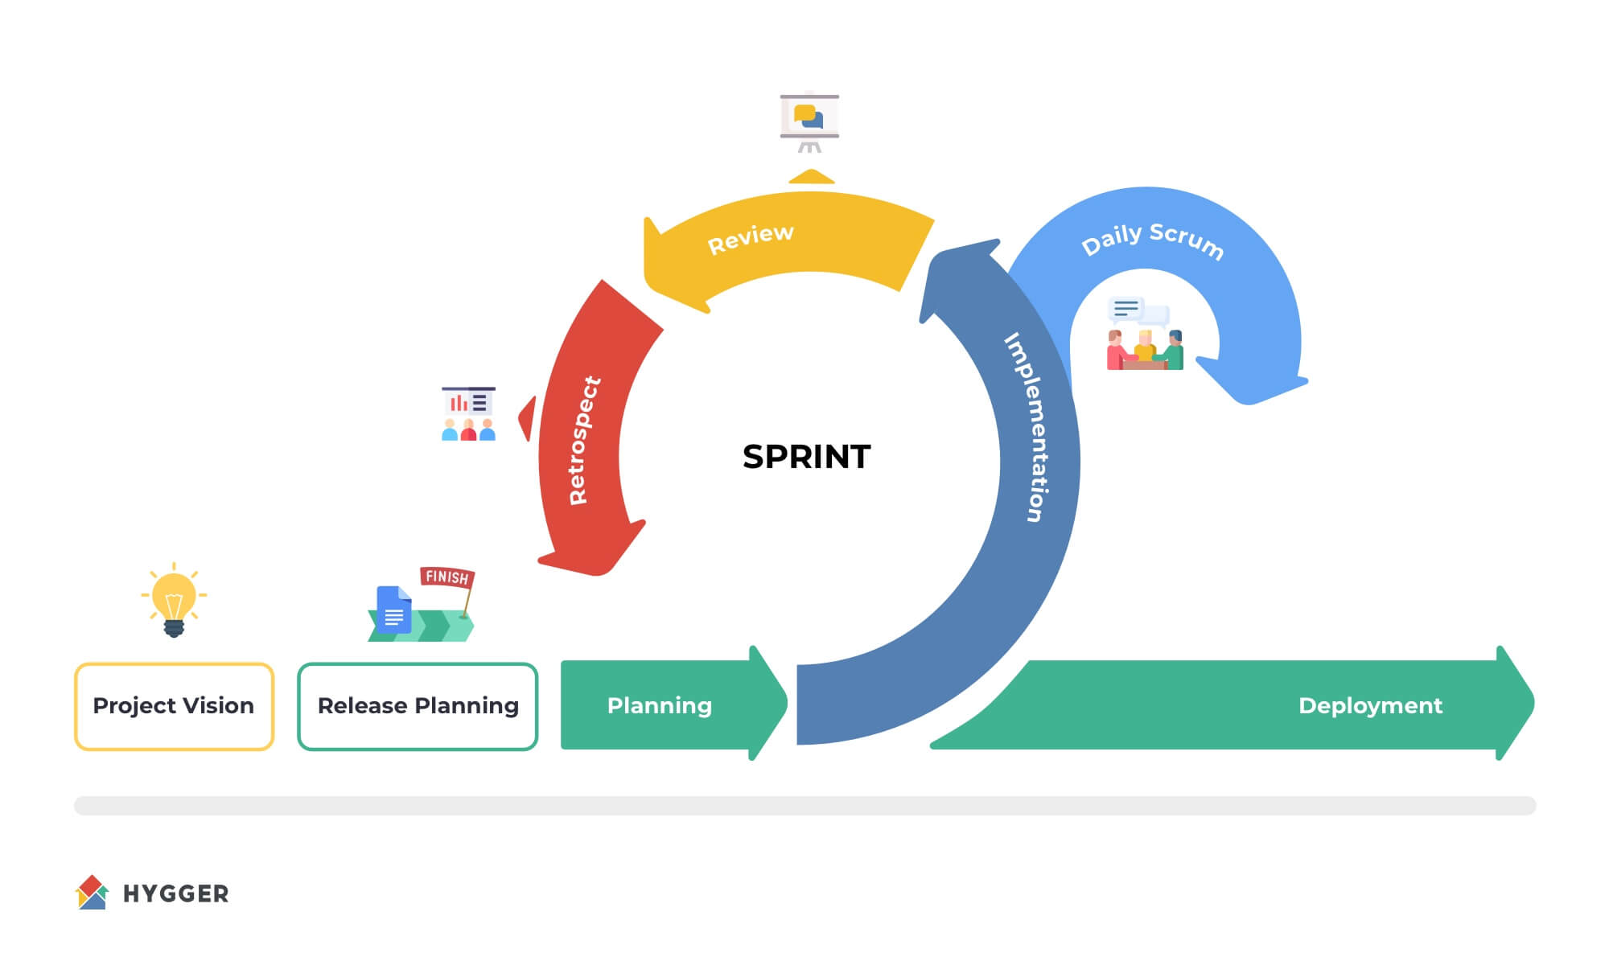

Figure 7: Scrum (Kukhnavets, P).

**How Does Scrum Operate?**

Scrum functions using a carefully considered set of principles and practices, each of which contributes to the effectiveness of the framework. It is based on the idea of time-limited sprints, which are typically between two and four weeks long. The development team concentrates on delivering a certain set of features or functionality during each sprint to ensure continued project advancement.

Scrum keeps track of all project features, tasks, and requirements in a prioritized product backlog that is compiled by the Product Owner. Prior to each sprint, the team chooses high-priority items from the backlog under the direction of the Product Owner. These meetings create a shared understanding and a sense of direction for sprints.

Everyday Standup Meetings allow for open communication where team members can discuss tasks, obstacles, and progress. Sprint Reviews presents sprint results to stakeholders and collects feedback for upcoming revisions. Following reviews, sprint retrospectives help identify areas for improvement, facilitate process improvements, and promote ongoing progress.

**Scrum Advantages to Home Assist:**

The fundamental tenets and practices of Scrum perfectly match the requirements of the Home Assist project:

Time management: In the context of Home Assist, Scrum's time-boxed sprints and frequent rituals are especially useful. These brief sprints guarantee steady advancement and regular delivery of functional software, exactly on schedule for the project's four-month duration.

Priority Focus: Home Assist may concentrate on providing high-priority things first thanks to Scrum's prioritized backlog management. To meet urgent user needs and corporate goals, this makes sure that crucial functionality, such customer registration, and service request submission, is swiftly made available.

Adaptability: The flexibility Home Assist needs to adjust to changing requirements or increasing client needs is provided by the inherent adaptability of Scrum, facilitated through routine inspection and adaption. The risk of a project derailing because of unanticipated developments is reduced by this capacity to pivot and modify.

Collaboration: Scrum's focus on cross-functional teamwork improves the project's efficiency for Home Assist. When team members with different skill sets collaborate, they develop more quickly and produce better results as they work together to complete tasks and overcome obstacles.

Incremental Delivery: Scrum's dedication to incremental delivery nicely complements Home Assist's goal to constantly deliver value to users throughout the course of the project. Scrum makes ensuring that users see real progress by concentrating on incremental releases of features at the conclusion of each sprint.

### 2.2.3 Rapid Application Development (RAD) (IBRAHEEM MOHAMMED IMADELDIN AWAD TP070765)

Rapid Application Development (RAD) is a software method of development that emphasizes quick prototyping and immediate feedback rather than detailed planning and extended development cycles. Its emphasis is on providing software rapidly, sometimes in a matter of weeks or months, and then iterating and making different adjustments to its evolutionary prototype based on the response to customer input (Chien, 2020).

**Working of RAD and how it can be implemented for development of the new Home Assist System.**

Figure 8: RAD Methodology Steps (WaveMaker, 2023)

The Rapid Application Development (RAD) methodology consists of 4 major steps which are depicted in Figure1. They are Analysis and Quick Design, Prototype cycles, Testing, and Deployment.

**Analysis & Quick Design:**

The first phase of the RAD methodology is to understand the system requirements (analysis and quick design). It takes a high degree of expertise or informed end-users to establish what the system's functions should be. This should be an organized discussion of the business issues that must be resolved. This stage of the process involves determining which programming languages and databases will be used. It also contains the interface design, which decides how the interfaces will look, and the data design, which determines what data will be required. The overall structure of the software is defined at this phase. Before beginning prototype development, it is critical to understand the system's needs (Ghadas et al., 2015). The use of Computer Assisted Software Engineering (CASE) tools is also recommended in the first phase to reduce time, which is one of the reasons why this approach is referred to as a quick system development methodology.

**Prototype Cycles:**

The project's second phase is a methodical cycle that includes three major steps: demonstration, refinement, and development. The first stage in this phase is to display the evolving prototype design, which in this case focuses on a basic Home Assist webpage design with a simple User Interface (UI). The main goal here is to get useful feedback from Home Assist at a face-to-face encounter. This input serves as a vital point for assessing what needs to be improved and what should be left alone.

The refining process takes center stage in the second step. This stage begins with a detailed examination of Home Assist's input, which acts as a guide for improving the design. The iterative process enables the adoption of essential revisions, resulting in a prototype that is more closely aligned with Home Assist's expectations.

The last step of the first cycle, which will be one of many, focuses on the creation of the evolutionary prototype. The development team methodically creates a dynamic and effective website based on Quick Design, making use of CASE tools as well as readymade templates and the complete revisions performed in response to Home Assist's input. This website has been meticulously designed with a set of features to respond to the demands of Home Assist, assuring a smooth and user-friendly experience. The cycle is repeated until a product that satisfies Home Assist's requirements is created, which will then proceed to the next phase of the project development.

**Testing:**

The third phase of the project is the testing phase where the system, which has been created by building on the evolutionary prototype, undergoes testing. Not many detailed tests are conducted in this phase, as each prototype was tested during the time of its creation in the previous phase before showing it to Home Assist and asking for their feedback. The final testing will be to check if all the functions required by Home Assist work as intended and that there are no issues that will hinder the working of the system as soon as it gets deployed.

**Deployment:**

The fourth and final phase is the deployment phase where a deployment method is chosen from a list of methods that are feasible for Home Assist. The different methods for deployment of Home Assist are Direct Takeover where the new system completely replaces the old one. It ensures a clean break from the old system, removing the need to maintain both old and new systems at the same time. It has the potential to significantly boost efficiency and production. On the contrary it could also be very risky to Home Assist as if any bugs and issues have not been ironed out before the deployment of the system, it would be detrimental to the operation of vendors, employees, and customers alike. It also costs money for the company to train employees in how to use the new system. Another method for deployment that can be used is Parallel Adoption where both the new and the old system are run together, which gives the employees of Home Assist the time they need to adjust to the new system. The drawback is that it comes at a high cost as it is expensive to run and maintain two systems simultaneously.

**BENEFITS**

To provide working products in a short amount of time, the Rapid Application Development (RAD) paradigm is a very successful methodology for software development that places an emphasis on rapid iteration and user input. Teams may concentrate on essential functionality and continual improvement by using Rapid Application Development (RAD) to divide the project into discrete phases, including business modeling, data modeling, process modeling, application development, testing, and turnover. The model's strength is its ability to quickly adjust to shifting requirements, guaranteeing that the final product not only meets initial goals but also changes in response to feedback and user demands. Compared to conventional procedures, this strategy guarantees a speedier delivery cycle and reduces the danger of major overhauls. Smaller teams can create high-quality software more quickly and effectively because to RAD's dedication to iterative development and minimum advance preparation. This dynamic environment encourages creativity and prioritizes customer happiness (5 Rapid Application Development Phases | Microsoft Power Apps, n.d.).

**DRAWBACKS**

Developers having a thorough knowledge of the approach and the capacity to build quick prototypes are required for RAD. Naturally developers with a lot of knowledge and experience in the field cost more than young, inexperienced developers to hire, which is a major drawback when it comes to managing the budget as more money must be spent by Home Assist to hire those experienced developers. Another drawback is that since the system is created in a short period of time the functionality and scalability of the system could be limited, which affects the ability of the system to be future proof. The aspect of RAD where multiple iterations, constant communication with and feedback from Home Assist can cause the requirements to become harder to track and keep note of during the development process (5 Rapid Application Development Phases | Microsoft Power Apps, n.d.).

### 2.2.4 SOFT SYSTEM METHODOLOGY (ABDULELAH HUSSEIN ABDULRAHMAN AL-KAF TP069319)

Soft Systems Methodology (SSM) is a method used in management science and systems, it’s a model business procedure that may be applied to managing organizational changes and general problem-solving. Peter Checkland created it in the 1970s as a technique for handling challenging organizational problems. Social science methodology (SSM) is mainly interested in solving complex issues where social systems, human perception, and values are important factors.(Mulder, 2022)

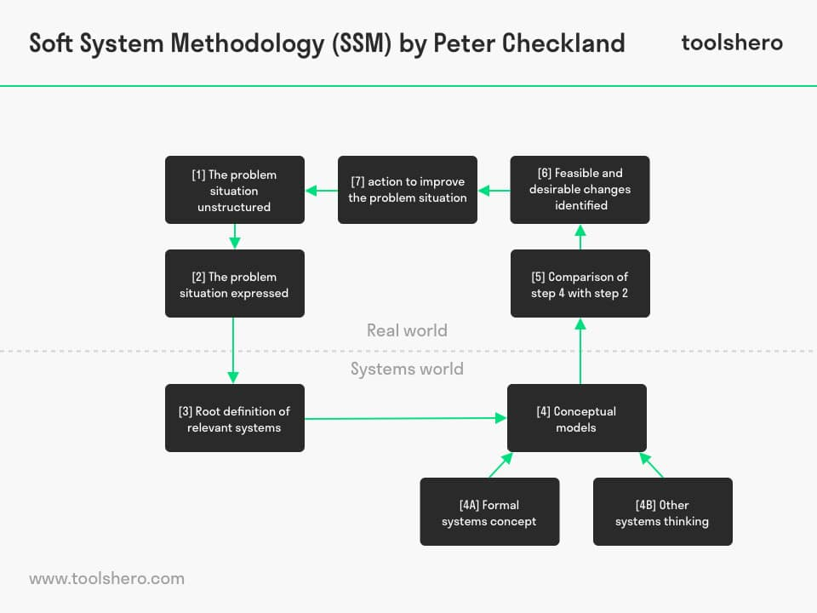

Figure 9,(Mulder, 2022)

HOW WOULD IT APPLY TO THE **“HOME ASSIST PROJECT”:**

1. **The problem situation unstructured:** The challenge now involves optimizing the administration of cleaning and associated services provided by Home Assist, integrating various stakeholders such as clients, cleaners, suppliers, and administrators into a streamlined, computerized framework. (indeed, 2023)
2. **The problem situation:** In order to understand the needs, expectations, and issues of every individual involved in managing services, scheduling, payments, and system features inside the "Home Service Management System," it is important to engage with the owner, manager, customers, vendors, and staff. (indeed, 2023)
3. **Root definition of relevant systems:** Develop root definitions outlining the primary objectives of the ‘Home Service Management’ System from a range of viewpoints:
   * Customer's perspective: A user-friendly system that makes payments and service requests simple.
   * Vendor's perspective: A platform for registering services, receiving payments, and managing service agreements.
   * Manager's perspective: A scheduling and reporting system for cleaners and business insights.
   * Administrator's perspective: A thorough management framework that monitors all aspects of operations. (indeed, 2023)
4. **Conceptual models:** Create detailed visuals and conceptual models that show the complex relationships that exist between clients, suppliers, cleaners, supervisors, and administrators inside the "Home Service Management System." The information flow, procedures, and interactions required for requests for service, scheduling, payments, and stakeholder interactions are shown in these models. (indeed, 2023)
5. **Comparison of step 4 with step 2:** Compare the developed conceptual models with the stakeholders' original problem statements. Make sure the models appropriately reflect the needs and expectations of stakeholders for the "Home Service Management System." (indeed, 2023)
6. **Feasible and desirable changes identified:** Determine the necessary improvements and modifications for the "Home Service Management System" by analyzing the conceptual models and stakeholder conversations. These might include features for collecting payments, managing service requests, registering vendors, organizing cleaning schedules, and providing thorough reports. (indeed, 2023)
7. **Action to improve the problem situation:** Create a working prototype or implementation strategy for the computerized "Home Service Management System" that incorporates the suggested modifications and features. Allocate resources considering the expected four-month schedule for system development and the owner's RM 60,000 budget. (indeed, 2023)

**Advantage / Disadvantage of Soft System Methodology**

|  |  |
| --- | --- |
| **ADVANTAGE** | **DISADVANTAGE** |
| **Structures complex problems:**SSM enables experts to better structure and arrange data about a complicated technological problem, enabling them to think of more useful modifications. (indeed, 2023) | **Guiding framework, not a blueprint:**SSM doesn't offer solid suggestions or courses of action. It provides a method for investigating various viewpoints and possible actions; however, the steps are dependent upon the circumstances and decisions made by the participants. (Mulder, 2022) |
| **Increases understanding of problems:**The SSM method can assist teams better understand how difficulties impact system requirements because it promotes open communication among those involved. (indeed, 2023) | **Limited guidance for implementation:** SSM offers less direction on the practical language of implementation, concentrating more on issue analysis and conceptual modeling. This implies that for enterprises to successfully execute the selected solution, SSM may need to be added by other approaches or skills. (Hanna Augustsson I, 2019) |
| **Identifies areas that need improvement:**The SSM's structure enables experts to identify certain parts of the system. to improve and what actions to take to implement improvements. (indeed, 2023) | **Time-Consuming**: It might take a while to define the issue scenario, develop conceptual models, and iterate through the many SSM phases. It may need large time investments from stakeholders, which makes it less practical for solving problems quickly. (Nair, Soft systems methodology for personalized learning environment, 2015) |

### 2.2.5 Rational Unified Process (RUP) (Abdul Shafey Khan - TP071166)

Rational Unified Process (RUP) is an extensive and iterative software development technique that focuses on the creation of high-quality software systems (Shafiee et al., 2020). This technique emphasizes cooperation and the inclusion of important stakeholders throughout the development lifecycle, making it adaptable to a range of project sizes and complexity. RUP would be used to the Home Assist project by breaking the development process up into discrete stages, each with well-defined deliverables and milestones (Anwar, 2014). An organized and iterative approach would be taken to the requirements collecting, system design, implementation, testing, deployment, and maintenance phases. Assuring conformity with industry standards and customer objectives, the Home Assist Home Service Management System would be developed successfully thanks to RUP's focus on flexibility and integration of best practices from many software engineering disciplines.

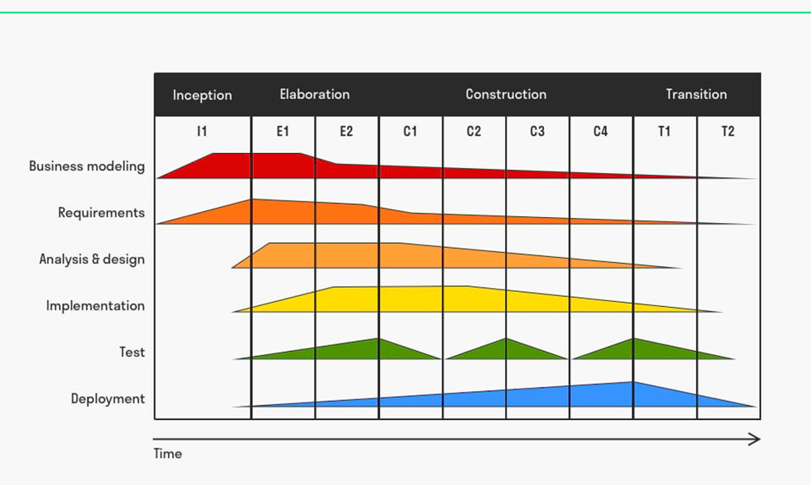

Figure 10: Stages of RUF (Ben Janse, 2023)

**The Phases of Rational Unified Process**

The four main stages of RUP are Inception, Elaboration, Construction, and Transition. A collection of associated tasks and benchmarks are represented by each phase, which leads the project team through the whole development process (Hanssen et al., 2005).

1. **Inception Phase**

The main goal of the Inception phase is to clearly define the project's objectives, scope, and business case. This entails determining the essential parts of the system, assessing any risks, and developing a high-level project plan. In addition, the team explicitly states the project's needs and goals at this phase. By doing this, the Inception phase ensures that all stakeholders agree with the project's objectives and expectations, laying the groundwork for the project's next phases (Shafiee et al., 2020)

1. **Elaboration Phase**

This stage is defined by a more thorough examination of high-risk elements found during the Inception phase. The project team takes on a more thorough system design, handles high-priority risks, and hones the project vision. An iteration plan is prepared for the Construction phase and a full project plan is produced. This phase's primary goal is to reduce risks and provide the groundwork for the next phases of development (Sudarma et al., 2021).

1. **Construction Phase**

The exact design is turned into a working system at this crucial stage of the development process. Iterative development, testing, and system component integration are all part of the process. The group is focused on finding quick solutions to problems and making sure the system satisfies requirements. Throughout this stage, testing and improvement must continue to create a dependable, high-quality system. The bulk of the coding and implementation happens during the construction phase, which is when the project becomes closer to its finished shape (Bernstein & Booch, 2020).

1. **Transition Phase**

This stage makes sure that the transfer from development to production occurs smoothly. This step involves putting the system into production settings, educating users, writing end-user manuals, and resolving any problems that may come up after the system has been deployed. In this phase, the project is concluded, lessons gained are recorded, and input is gathered for potential improvements. The project will have formally ended by the end of Transition, at which point the system ought to be fully functional and the focus will shift to continuing maintenance and support (Hanssen et al., 2005).

This stage makes sure that the transfer from development to production occurs smoothly. This step involves putting the system into production settings, educating users, writing end-user manuals, and resolving any problems that may come up after the system has been deployed. In this phase, the project is concluded, lessons gained are recorded, and input is gathered for potential improvements. The project will have formally ended by the end of Transition, at which point the system ought to be fully functional and the focus will shift to continuing maintenance and support (Hanssen et al., 2005).

**Application to Home Assist and Advantages**

The Home Assist project may benefit significantly from the Rational Unified Process (RUP) in terms of software development lifecycle structure. RUP offers Home Assist, an organization that wants to automate its service management system, an organized approach to lead the project from the start to finish. Home Assist may use RUP to create a high-level project plan, identify important stakeholders, and describe the project vision during the Inception phase, which will guarantee that the project's goals and scope are understood. Home Assist may improve the project concept and reduce high-risk parts during the Elaboration phase, which lays the groundwork for future development activities.

The fundamental RUP phase of construction corresponds with Home Assist's requirement to develop and test its service management system separately. Through the implementation of manageable iterations, Home Assist can guarantee that the system satisfies criteria and rapidly resolves any difficulties (Mohd et al., 2016). For Home Assist, in particular, the iterative nature of RUP is advantageous as it provides flexibility in responding to evolving needs and integrating stakeholder input throughout the development process.

Furthermore, Home Assist's objective of a seamless transition from development to deployment is in line with the Transition phase. To ensure a successful system rollout, RUP assists Home Assist with creating end-user documentation, leading training sessions, and resolving post-deployment difficulties. Because RUP is flexible, Home Assist may customize its procedures to meet the unique requirements of the project (Mohd et al., 2016). This makes RUP a useful approach for automating service management and improving overall operational effectiveness.

**Drawbacks and Potential Solutions**

The Rational Unified Process (RUP) has limitations despite its advantages, and the Home Assist project's implementation will not be effective unless these issues are recognised and addressed. The apparent overhead and supposed complexity of RUP are two significant concerns. Particularly for smaller projects like Home Assist, the comprehensive documentation requirements and phase-by-phase breakdown may be considered time-consuming. This complexity may make it difficult to understand and use the approach in an efficient manner (Jatnika et al., 2023).

Additionally, since RUP is organized and intended for larger-scale projects, it could be challenging to adapt to quickly changing needs, which are common in the dynamic operating environment of Home Assist. This might lead to delays and make it more difficult for the project to adjust to changing requirements (Sudarma et al., 2021).

There are a few possible strategies that Home Assist may put into practice to deal with these issues. It is crucial to modify RUP to fit the unique requirements and project scope. This involves implementing RUP components and documentation procedures in a way that is appropriate for the scope of the project, preserving key procedures while reducing unnecessary overhead.

Adaptive methods may help reduce the issues associated with flexibility with each iteration. The project will continue to be responsive to changing demands if it places a strong emphasis on ongoing input and adjusts requirements throughout iterations. The development team may overcome any obstacles resulting from the formal character of RUP by having regular training sessions and communicating clearly about the reasoning behind each step (Bernstein & Booch, 2020).

### 2.2.6 V-Model (Amanullah Ghauri -TP071215)

The V-Model in software development is a structured process that emphasizes the association between each development phase and its respective testing phase (Oppermann, 2023). It features verification phases such as "Concept of Operations" and "Requirements and Architecture" on the descending left side of the "V," progressing towards "Detailed Design" and then "Implementation." After coding, the model ascends on the right side to corresponding validation phrases like "Integration, Test, and Verification" and "System Verification and Validation. This model is particularly useful when requirements are clear from the onset and the project scope is well-defined.

The V-Model is apt for the Home Assist system, where we know what needs improving. This model's careful checks at each phase make sure new features like booking services and handling payments are built right and work well. It's a step-by-step way to make sure the software we create is of high quality and does exactly what it should, which is key for a system with many different parts like Home Assist.

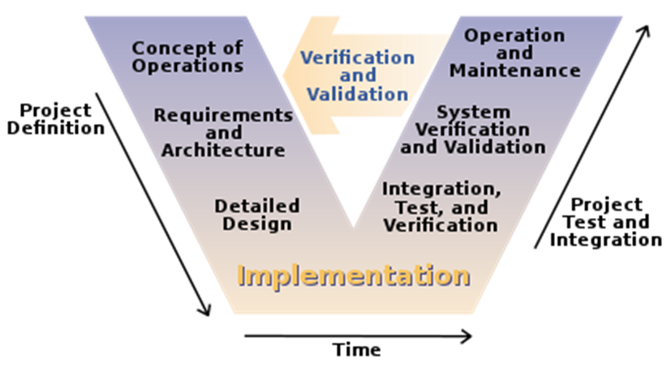

*Figure 1: An overview of the V-Model's structured approach to software development.*

**Implementation of the V-Model:**

**Phase 1: Concept of Operations**

We will initiate the V-Model for the Home Assist system with the "Concept of Operations" phase, which sets the foundational goals and parameters. This step includes detailing the system's objectives, aligning with business strategies, and understanding constraints. We'll also prepare a comprehensive checklist addressing the reasons for upgrading the system, defining stakeholder roles, and mapping out the internal and external environments the system will engage with.

**Phase 2: Requirement Analysis & Architecture**

Moving to the "Requirements Analysis & Architecture" phase, we will gather user requirements through interviews, surveys, and observations, which will then be detailed in a System Requirements Specification (SRS) document. This document will list both functional and non-functional requirements. Next, we'll conduct a thorough system design study to determine the feasibility of these requirements and create a software specification document. This will outline the system's structure, scenarios, and test plans. Finally, we'll design the software architecture, including database structures and module functionalities.

**Phase 3: Detailed Design**

In the "Detailed/Module Design" phase, we will break down the Home Assist system into smaller, manageable modules. For each module, we'll define the specifics, including database tables with their types, sizes, and constraints, as well as the detailed interfaces. Additionally, we'll specify the exact inputs and outputs for each module to ensure clarity and precision in development.

**Phase 4: Implementation**

During the "Implementation" phase for the Home Assist system, our focus shifts to actual development. Here, we translate detailed designs into workable code, building out each module according to the specifications laid out in the previous phase. It's a critical step where all the planned functionalities begin to take shape, turning concepts and detailed plans into a functioning software product.

**Phase 5: Verification & Validation**

During the "Verification and Validation" stage, we will conduct thorough testing for the Home Assist system. This includes unit testing each component to find and fix bugs, integration testing to ensure modules work together smoothly, system testing to verify the complete system's functionality against requirements, and finally, user acceptance testing to confirm the system meets user expectations and operational needs.

**Phase 6: Operation & Maintenance**

In the final phase, the Operation & Maintenance phase, we'll establish the best practices for the Home Assist system's day-to-day operations, including problem management, help desk operations, and release management. We will also focus on ensuring quality assurance, overseeing IT asset management, and maintaining hardware. Additionally, we'll plan and monitor system capacity and maintain service management activities to ensure smooth, continuous operation.

**Benefits of using the V-Model**

Adopting the V-Model for the Home Assist project promises several benefits. It will enhance the quality of the software from the outset, leading to a stronger and more user-friendly system. The structured approach of the V-Model helps in mitigating risks and improves overall project management. It fosters collaboration among the teams, improving efficiency in development and testing phases. Communication is streamlined, ensuring clarity in requirements and objectives. The V-Model's insistence on detailed documentation will also facilitate better maintenance and updates in the long run (Oppermann, 2023).

**Drawbacks of using the V-Model**

While the V-Model ensures quality and thoroughness in the Home Assist project's development, it has limitations. The model's rigidity can pose challenges if project requirements evolve, potentially leading to difficulties in adapting to changes. The focus on detailed planning and documentation can extend timelines and consume considerable resources. Moreover, the V-Model's structured nature limits the agility that might be required for iterative development and rapid response to feedback. Additionally, its emphasis on testing at every stage, while beneficial for quality assurance, may result in prolonged development cycles.

### 2.2.7 Design Thinking (Muhamad Ahmad Al Muhdar -TP070208)

Introduction to Design Thinking:

Design Thinking is an iterative, human-centered method to problem solving that prioritizes creativity, empathy, prototyping, and testing. To develop creative solutions that solve serious problems, it pushes teams to have a thorough understanding of the requirements and experiences of end users. When the objective is to improve user experiences and develop goods or services that appeal to the target audience, design thinking is very useful.

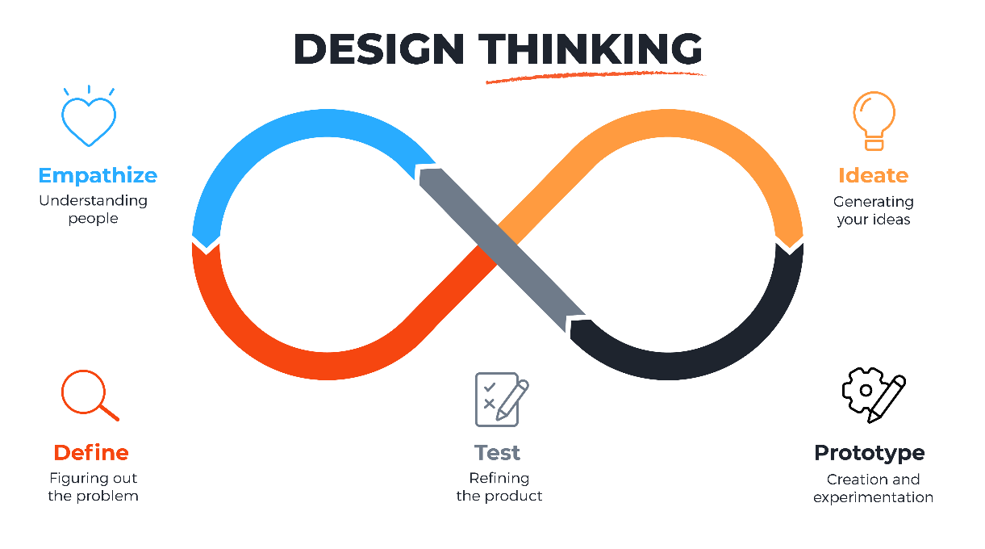

Applying Design Thinking to Home Assist:

Empathize:

Knowing Stakeholders: During the first stage, the Home Assist team would thoroughly develop themselves in the perspectives of stakeholders, such as clients, managers, housekeepers, outside suppliers, and the Home Assist owner. To obtain a thorough understanding of their requirements, problems, and goals, this entails conducting interviews, making observations, and gathering feedback.

Define:

Problem Definition: Clearly identify the main obstacles and possibilities in considering the information gathered. For Home Assist, this can require detecting the errors in the current manual procedures, recognizing the unfulfilled needs of clients, and discovering opportunities to improve coordination with outside providers.

Ideate:

Brainstorming Solutions: Arrange group brainstorming meetings with a range of participants. Come up with a range of concepts to boost customer satisfaction, increase Home Assist's operational efficiency, and maximize cooperation with outside vendors. Promote originality and receptivity to fresh ideas.

Prototype:

Provide Solutions: Create flexible prototypes or mock-ups of possible fixes. This could entail developing visuals for an automated payroll system, an enhanced vendor management procedure, or a digital platform for consumer interactions. Prior to a project's complete implementation, prototypes aid with concept visualization.

Test:

Collect Feedback: Put the suggested solutions through trial programs or small-scale testing. This can include putting a new digital interface to the test with a small group of clients or testing an automated payroll system with a designated group of administrators. Get input from interested parties to determine how successful the solutions are.

Implement:

Iterative Implementation: Work on the solutions and adjust based on the input you've received. Gradually put the enhanced procedures into practice, making sure that all parties are aware of the changes and that they are comfortable with the shifts. It is essential to have ongoing feedback loops to adjust the solutions that are put into place.

Advantages of Design Thinking:

User-Centric Solutions:

Design Thinking organizes the solution creation process around the needs of the user. This guarantees that Home Assist's services are not only effective but also customized to meet the specific requirements and preferences of its clients, administrators, cleaners, and outside contractors.

Enhanced Collaboration:

By bringing in a variety of stakeholders, Design Thinking encourages cooperation. Because of this inclusion, all viewpoints are considered, resulting in more complete and broadly accepted solutions. Enhanced cooperation can help improve bonds between Home Assist teams and outside partners.

Iterative Improvement:

Because Design Thinking is iterative, Home Assist can adapt to user feedback and adjust over time. This flexibility guarantees that the business may react immediately to evolving needs, resulting in services that are effective and relevant for an extended period.

Disadvantages of Design Thinking:

Time-consuming:

Design thinking involves several stages, including empathy, ideation, and prototype, and can be time-consuming. It may seem difficult to go through the lengthy Design Thinking process when decisions must be made quickly.

Resource-intensive:

A significant commitment of time, staff, and maybe outside expertise may be needed to implement Design Thinking. It could be difficult for small enterprises or those with limited resources to dedicate themselves to the process's requirements.

Subjectivity:

Because Design Thinking places a strong emphasis on empathy and the user's perspective, it may add subjectivity into the process of making decisions. It could be necessary to give considerable thought and strategic alignment to Home Assist's overall goals to balance user preferences.

# 3.0 SYSTEM ANALYSIS

The evaluation of a technological system, such as a software program, to debug, create, or enhance it is called a system analysis (Indeed Editorial Team, 2023). By conducting thorough investigations, analysts can find design incompatibilities, end-user accessibility issues, and coding errors. To appropriately approach their study and do a good systems analysis, professionals must first comprehend the requirements of a software product or package. There are several system analysis methods for the system of Home Assist but the two analysis methods that were used are Business Intelligence Analysis and SWOT Analysis.

## 3.1 Business Intelligence Analysis.

Starting with Business Intelligence (BI) analysis, the process of analyzing data and presenting useful information to executives, managers, and other corporate end users is known as business intelligence (BI) analysis. It is facilitated by technology (Stedman & Burns, 2023). To enable organizations to gather data from both internal and external sources, prepare it for analysis, develop and run queries against the data, and produce reports, dashboards, and data visualizations to make analytical results available to both corporate decision-makers and operational staff, business intelligence (BI) encompasses a variety of tools, applications, and methodologies.

To gather information as realistically as possible about how Home Assist staff operate, some techniques used for this analysis included interviewing both customers and workers. This increased the reliability of the information obtained as the information was not just collected from one group thereby reducing the chance of biased input. Another technique used was observation, which involved observing home assist staff members working, to draw well-informed and accurate conclusions. Both methods fall under the category of qualitative research techniques.

**BENEFTIS**

BI systems support an organization's decision-making process by collecting, storing, accessing, and analyzing business data. These systems will often demonstrate business intelligence in the following domains: statistical analysis, inventory and distribution analysis, market research, product profitability, customer segmentation, customer profiling, and customer assistance, among others.

Benefits of Business Intelligence Analysis include accurate reporting. Through reliable reporting, Business Intelligence (BI) provides Home Assist with essential insights that improve operational efficiency and decision-making. In-depth reports may be produced by BI technologies by automatically synthesizing data from a variety of disciplines, including financials, customer feedback, and service performance (Schmidt, 2023).

Team productivity can be greatly increased by putting in place a Business Intelligence (BI) solution. The Business Intelligence (BI) system can process information faster than manual methods, allowing it to spot problems and provide solutions more quickly. For example, it can identify inefficiencies in cleaner scheduling or vendor management immediately, allowing for speedy fixes. Moreover, BI software can make recommendations for ways to improve operations, assisting Home Assist in overcoming obstacles to efficiency. Improved productivity not only saves time but also allows employees to concentrate on more strategic work, which raises the company's overall operational effectiveness (Schmidt, 2023).

## 3.2 SWOT Analysis.

SWOT analysis was the second analysis technique that was applied. To identify and evaluate the opportunities, threats, weaknesses, and strengths of a project or commercial endeavor, a SWOT analysis is a strategic planning approach that is employed. It helps to understand how the entity is affected by resources and skills that are both internal (strengths and weaknesses) and external (opportunities and threats) (“SWOT Analysis,” 2023).

To gather information for the SWOT analysis customer feedback was obtained via questionnaires and surveys.

Strengths: The broad range of services that Home Assist offers, from ordinary cleaning to specialized jobs like plumbing and air conditioning, is one of its strongest points. The organization is positioned as a one-stop shop for property upkeep because of its diversity. Furthermore, the company's diverse workforce—which includes administrators, cleaners, and other workers—ensures a wide range of skill sets, allowing it to successfully address a range of client demands.

Weaknesses: One major shortcoming of the company's existing operating model is its heavy reliance on manual processes for scheduling and payments. This dependence may result in mistakes and inefficiencies that affect the provision of services. Dependency on outside suppliers for some services also adds quality and reliability issues that may have an impact on client satisfaction.

Opportunities: Using technology in Home Assist's operations is a big possibility. Scheduling, payment, and vendor management are examples of procedures that might be digitalized to greatly increase accuracy and efficiency. The market for property services is growing, which gives Home Assist chances to grow its clientele, broaden its range of services, and position themselves better in the industry.

Threats: There is a threat from the competitive environment because many businesses provide comparable property services. For Home Assist to keep and expand its clientele, it must set itself apart. implementing new technology might be advantageous, there are risks and obstacles involved, such staff and customer adaptation and system integration problems.

**BENEFITS**

Conducting a SWOT analysis has several advantages. Because it just requires someone with business expertise and doesn't require substantial training, technical abilities, or outside experts, it is a cost-effective solution. SWOT analysis may be used to identify favorable or unfavorable environmental conditions for any purpose, it is widely applicable in a variety of contexts, from competitive analysis to strategic planning. In addition, it encourages candid communication among staff members, which unites everyone in the pursuit of organizational success by illuminating the company's advantages, disadvantages, opportunities, and dangers. This cooperative strategy is essential for moving a business closer to its objectives (Contributor, 2022).

# 4.0 SYSTEM DESIGN. (INDIVIDUAL)

## 4.1 Data Flow Diagram (DFD) level 0 (Abdulrahman Gamil Mohammed Ahmed TP071012)

An illustration of how information flows through a system or process is called a data flow diagram (DFD). It displays the routes that data inputs, outputs, storage places, and arrows follow to get to various points. DFDs may be used to examine and model new or existing systems. They might be as straightforward as summaries or as intricate as multi-level models. They successfully communicate complex ideas through graphics, and they are well-liked by audiences from a variety of backgrounds, including CEOs and programmers. However, now, database-oriented, real-time, or interactive software or systems are harder to visualize with DFDs (What is a Data Flow Diagram, 2023).

The Data Flow Diagram (DFD) and Extreme Programming (XP) approach are closely intertwined in the Home Assist project. In line with the principles of XP, the DFD offers a graphic depiction of the information flow that occurs within the system. The DFD created a map that exemplifies the core values of XP, which are feedback, boldness, respect, communication, and simplicity.

The DFD's focus on stakeholder contact and feedback loops aligns nicely with XP's development methodology. It provides an example of the flexible approach of XP and shows how information exchange is included into every stage of the development of Home Assists.

The quality assurance (QA) nodes in the DFD reflect user interactions and automated testing checkpoints, which are essential elements of XP. The image becomes a brief reminder of XP's commitment to stability and continuous improvement.

The DFD also includes a graphical representation of new components, such as coupon accommodation, that illustrate how XP's adaptability is integrated into the Home Assist system. Within the parameters of the Home Assist project, the DFD effectively transforms into a visual narrative that embodies the XP values of cooperation, adaptability, and quality.

Figure 11: data flow diagram (DFD) level 0

## 4.2 Use Case Diagram (Yazen abobakr ahmed almehdhar - TP069210)

A Use Case Diagram is a useful tool for understanding how various actors—users and external entities—interact with the system to accomplish goals and for modeling the functional requirements of a system. It is essential to the Home Assist project and the Scrum methodology in several ways.

Several actors are involved in the Home Assist project, including vendors, administrators, cleaners, customers, etc. Every actor uses the system in a different way. These actors can be clearly represented as separate elements in a use case diagram. It also aids in the definition of the use cases for the system, which stand in for features or services offered by the system, like "Request Service," "Manage Cleaner Schedules," "Manage Payments," and "Vendor Registration."

Use case diagrams use associations to visually represent the relationships between actors and use cases. Customers, for example, engage with use cases such as "Request Service" and "Submit Review," whereas administrators work with use cases such as "Manage Cleaner Schedules" and "Manage Payments." Stakeholders, such as the development team and product owner, can better grasp user interactions and the system's high-level functionality with the help of this visualization. Additionally, it makes it easier to prioritize use cases according to their significance and the needs of the customer—a critical component of Scrum's emphasis on generating incremental value.

Use case diagrams also provide the important benefit of establishing traceability between user requirements and system functionality. Traceability is essential to Scrum's value-delivery methodology because it guarantees that the system meets user needs and business objectives. Use case diagrams are a useful tool for communicating with different stakeholders, such as the development team, external vendors, and the product owner. They encourage agreement on the operation of the system and user interactions as well as cooperative dialogues and shared understanding.

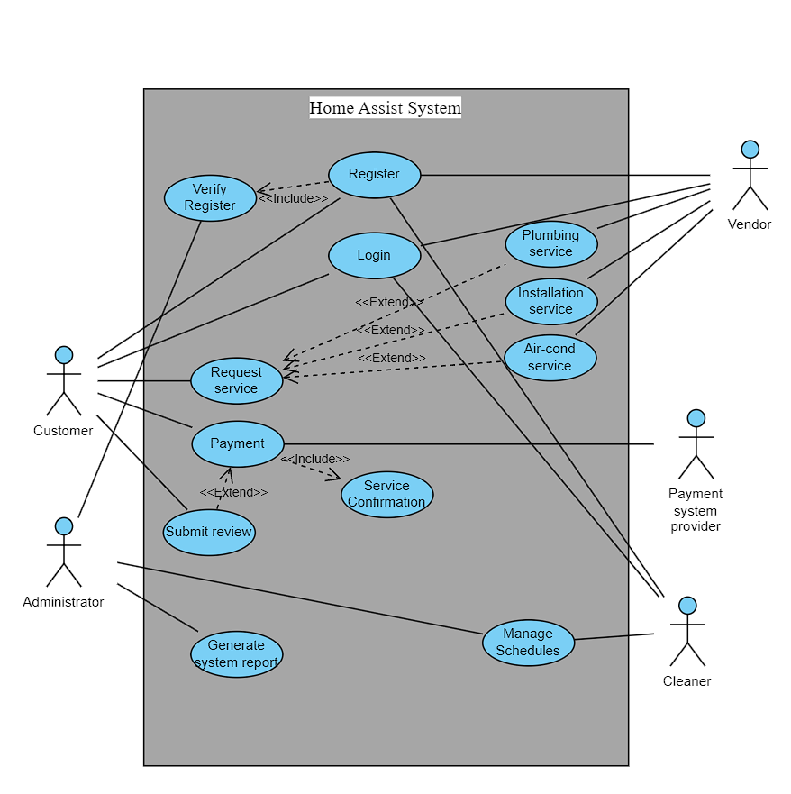

Figure 12: Use Case Diagram

## 4.3 Class Diagram (Ibraheem Mohammed Imadeldin Awad TP070765)

An essential exchange medium, the class diagram serves as a visual representation of the system's architecture, bridging the gap between technical and non-technical stakeholders and facilitating collaborative discussion. It is a modeling technique that is seamlessly integrated with the Rapid Application Development (RAD) methodology for the Home Assist project. This approach is critical to supporting iterative development; as Home Assist evolves, the class diagram can be dynamically updated to reflect new user feedback, ensuring that prototypes progressively refine towards the final system.

Class diagrams are a natural fit for systems designed in object-oriented languages since they naturally work well with object-oriented programming, the foundation of RAD. RAD's fundamental principle of identifying reusable components is made possible by its ability to visually divide the system into distinct classes that may be separately built, tested, and improved. This modularity facilitates effective problem-solving by making it possible to identify problems with the system's architecture and quickly find solutions.

A class diagram for Home Assist would carefully lay out the organizational structure, identifying key players like Customers, Services, Employees, and Vendors, along with their connections. It streamlines the development process by laying the groundwork for managing intricate features like payment processing, scheduling services, and feedback management. The class diagram would change to reflect improvements as the project went on, solidifying its position as a key component of the RAD process and guaranteeing the delivery of a reliable, flexible, and user-focused home assist system.

Figure 13: Class Diagram based on RAD.

## 4.4 Entity Relationship Diagram (Abdul Shafey Khan-TP071166)

Entity-Relationship Diagram (ERD) is a suitable modelling technique for representing the key connections between data inside the system in the framework of the Rational Unified Process (RUP) methodology used for the Home Assist project. When it comes to representing the entities (cleaners, customers, services, and suppliers) in the Home Assist ecosystem and showing the relationships between them, ERDs are highly beneficial. This perfectly fits with RUP's early development focus on comprehending and defining the system architecture. Using ERDs, Home Assist can provide a complete foundation for the database design phase of the RUP approach by illustrating the numerous entities, their attributes, and the connections between them.

With a focus on service management, vendor management, customer management, cleaner management, and payment management, Home Assist recognizes that an ERD is an effective tool for defining the complex network of connections across these organizations. It makes a thorough database design possible by delineating the organization and dynamics of the system. Ensuring a common knowledge of the system's architecture across project stakeholders is made possible by the visual representation that ERDs provide. In the end, using ERDs is consistent with Home Assist's objective of optimizing its service management system's overall effectiveness and simplifying operations.

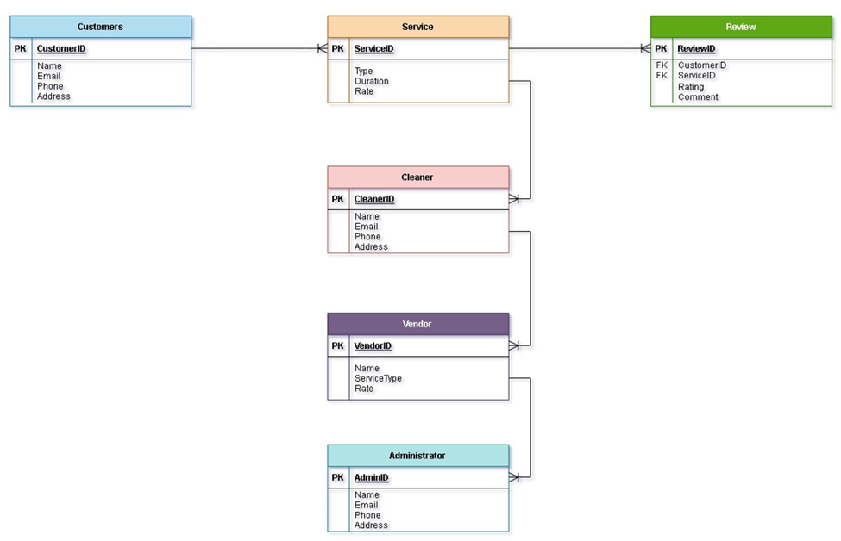

Figure 14: An Illustration of Home Assist’s Operations via ERD Diagram

## 4.5 Sequence Diagram (Amanullah Ghauri – TP071215)

In the context of the V-Model methodology, which emphasizes verification and validation at each phase of development, the sequence diagram is a highly relevant modeling technique. A sequence diagram is a UML tool used to represent interactions between objects in a system, detailing the order of these interactions (Wesbey, 2023).

In applying the V-model methodology to the Home Assist project, the sequence diagram serves as an essential modeling technique to visually map out the interaction between system entities throughout the service management lifecycle. It provides a clear view of the sequence of events, illustrating how the system components, such as the Customer, Home Assist System, Payment System, and Service Vendor, communicate and respond to each other from the initial service request to the final execution and feedback collection. This allows for precise verification of the system design against user requirements and ensures that each interaction is accounted for and can be validated in the corresponding test phase. Furthermore, the sequence diagram aids in identifying potential issues in the interaction flow, offering a detailed perspective that is crucial for the iterative validation steps of the V-Model.

Following is a sequence diagram capturing the service request functionality in the Home Assist system. In this sequence diagram, a customer requests a service, the system checks with the vendor, schedules the service, processes payment, and collects feedback after the service is completed.

**Sequence Diagram:**

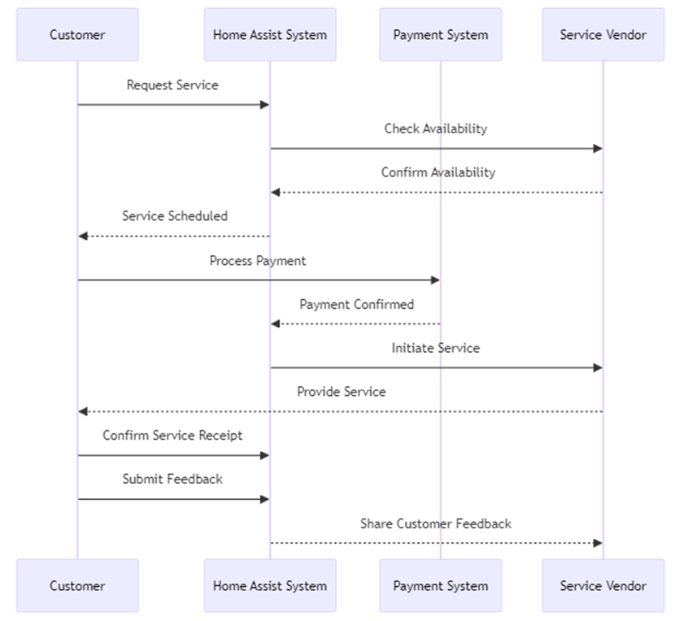

Figure 15: A sequence diagram for the service request functionality.

## 4.6 State Machine Diagram (ABDULELAH HUSSEIN ABDULRAHMAN AL-KAF – TP069319)

A state machine diagram is a type of behavioral diagram that shows the different states of an entity and the progression of states that an item experiences in reaction to various inputs and events. Given that Home Assist is a service-oriented system, incorporating a State Machine Diagram compliant with the Soft System Methodology (SSM) can offer an organized method of handling different system states and transitions. SSM focuses about people’s methods of problem-solving while attempting to address difficult real-world problems.

**Stakeholder Focus:** The State Machine Diagram considers various stakeholders' interactions within the system (customers, vendors, managers, cleaners) aligning with SSM's emphasis on understanding stakeholders' perspectives and needs.

**Iteration and Feedback:** The iterative nature of the diagram, allowing transitions between states based on user actions, corresponds to SSM's iterative approach, accommodating feedback and adapting to changes over time.

**Adaptive Responses:** SSM emphasizes adaptability to changing situations. The diagram allows for different scenarios such as payment delays, coupon applications, and service completions, enabling the system to respond flexibly.

In the context of the Soft System Methodology framework, this State Machine Diagram offers a graphical representation of the constantly changing character of interactions within Home Assist, which helps understanding, planning, and development of the system's functionality and reactions to different events and states. (Guthrie, 2022)

**

Figure 16: State Machine Diagram based on SSM.

## 4.7 Activity Diagram (Muhamad Ahmad Al Muhdar – TP070208)

The activity diagram, which describes the sequential process of offering services to clients, functions similarly to a road map for Home Assist. The process begins with a customer requesting assistance and includes steps like scheduling, verifying information, and allocating the right staff for the task, whether they are internal employees or outside contractors. The diagram also shows decision points and feedback loops, such as getting customer input to keep becoming better. It concludes with crucial actions like collecting payments and generating company reports. This flowchart facilitates communication and teamwork among Home Assist employees, ensuring that clients receive excellent care. It functions as a visual guide to maintain efficiency and organization.

Figure 17: Home Assist Service Process Activity DiagraA diagram of a flowchart

Description automatically generatedm

# 5.0 IMPLEMENTATION AND DEPLOYMENT.

## 5.1 Construction

|  |  |
| --- | --- |
| Visual Studio Code | Used to code and program the Home Assist website. It functions as an integrated development environment (ide), making it easier to write code, troubleshoot problems, and combine databases with websites. |
| MySQL Database | Oversees and maintains the Home Assist system's data. It ensures smooth program functioning by offering a dependable relational database management system (RDBMS) for effectively organizing, retrieving, and storing data. |
| Slack | A platform for team members collaborating on the Home Assist project to communicate in real time. It facilitates communication, guaranteeing quick replies and effective information exchange. |
| Selenium WebDriver | A program that runs tests automatically to make sure the Home Assist system works. It verifies that the program is accurate, spotting and fixing possible problems as they arise. |

## 5.2 Proof of Concept

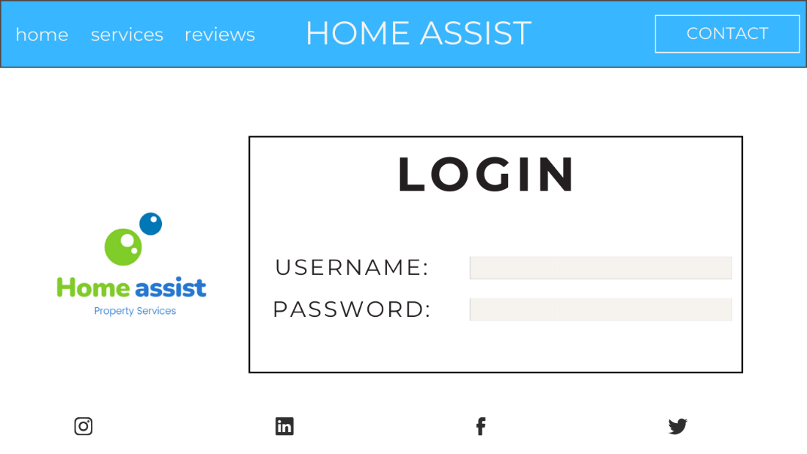

Figure 18: login

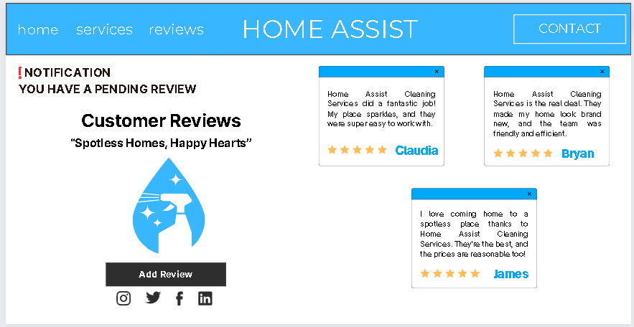

Figure 19: Reviews

## Cleaners Booking:

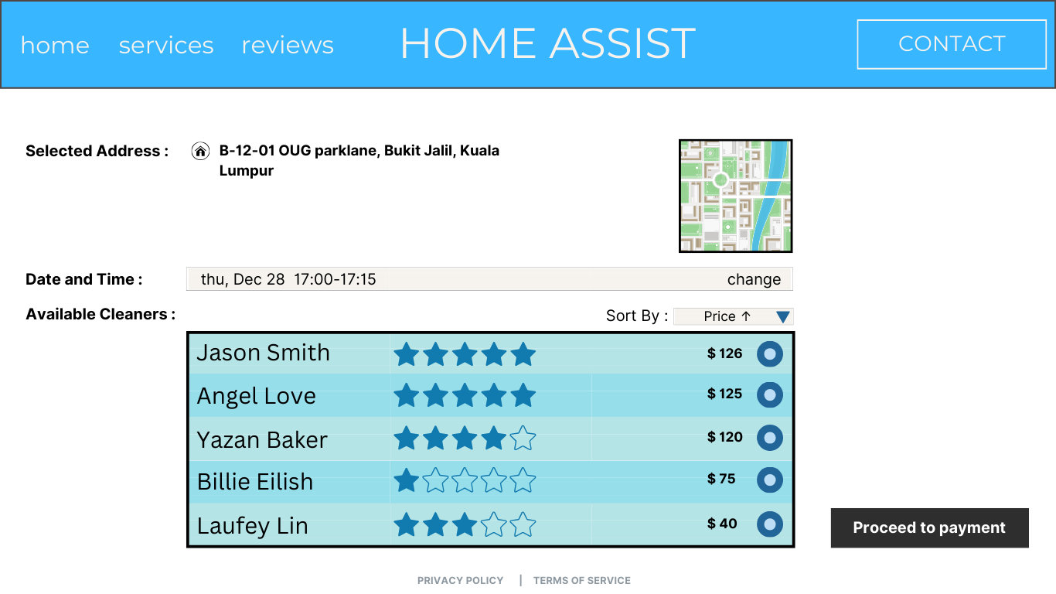

Figure 20: Booking

## Payment Processing:

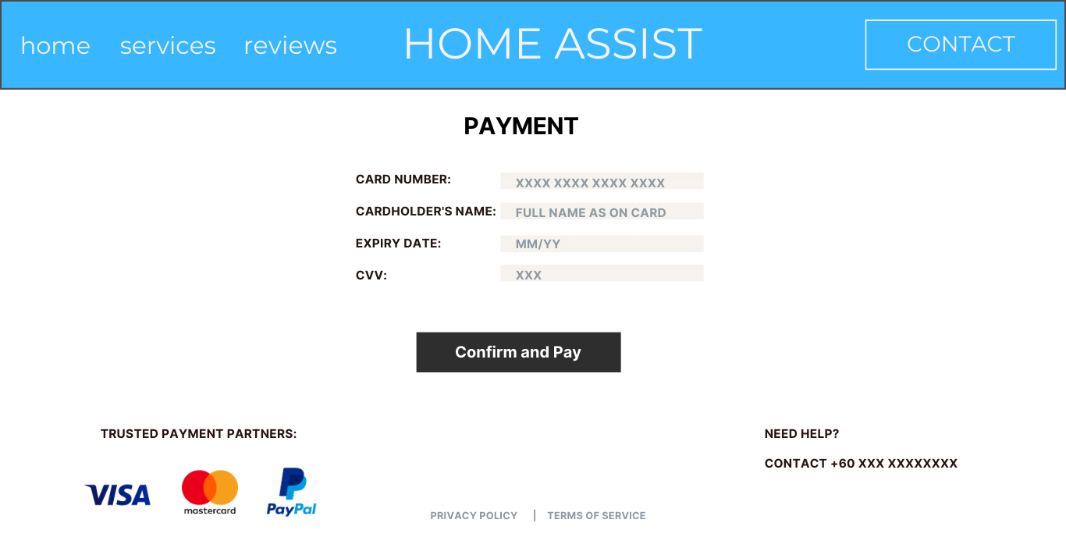

Figure 21: Payment Processing

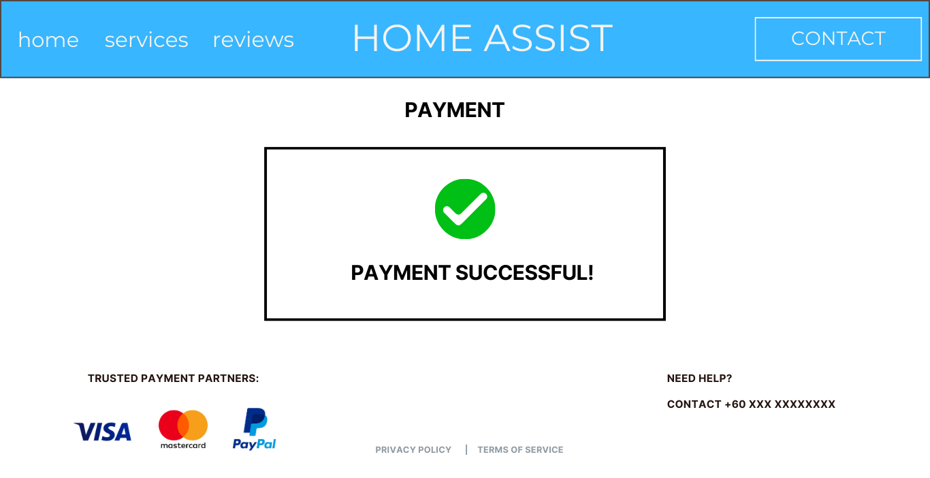

Figure 22: Payment successful page

## Viewing Reviews:

Figure 23: prints all the reviews based on customer ID.

## Viewing Payment Sheet :

Figure 24: Payment Sheet

## 5.3 TESTING

**1) Acceptance Testing**

We're setting up an acceptance testing phase for the Home Assist system, which is a critical step in making sure everything works perfectly. Acceptance testing is typically performed by end-users or client representatives, who are the intended users of the software. They validate the software's functionality and usability, simulating real-world usage scenarios to ensure the software meets their needs and preferences, providing critical feedback and final approval before it is released to production (testsigma).

These testers will go through common tasks to spot any issues, like bugs or confusing parts of the system. Their feedback is vital because it helps us see things from a user's perspective. We want to know what they like, what frustrates them, and what could be improved. By engaging with the system, users can provide direct feedback on its functionality and usability, which is critical for a service-oriented business model like Home Assist.

After the testing, we'll gather all the feedback for a full review. This is where we'll see what needs to be changed or fixed. We're looking for honest, direct suggestions that can make the system better for everyone.

Finally, we'll use this feedback to polish the Home Assist system. Our goal is to have a system that's not just functional but also easy and pleasant for all our users. We're committed to making sure that when Home Assist goes live, it'll meet everyone's needs and exceed their expectations.

**Procedure**

Objective: To ensure the system meets the end-users' requirements and gains their approval before going live.

**Test Planning:**

* Determine test objectives based on user requirements and create a focused testing regimen to cover all user scenarios for the Home Assist system.

**Test Design:**

* Develop test cases that mimic real-world usage by customers and vendors, ensuring compatibility and efficient workflows.

**Test Execution:**

* Conduct the tests with actual end-users, including representatives from administrators, cleaners, vendors, and customers.
* Document each test case execution, noting the expected and actual results, and log any irregularities or issues.

**Summary Reporting:**

* Analyze the results from the acceptance tests to identify any patterns in the issues encountered.
* Compile the data into a summary report that will be reviewed by the stakeholders to make informed decisions on any required changes before the system release.

**Example Test Cases:**

**Test Case 1:**

TEST DATE / TIME: 01/12/2023 - 10:30 AM

TEST BY: Hailey Jackson

PROJECT ID: PR4532786

SYSTEM TITLE: Home Assist System

| **Test Case** | **Test Type** | **Test Steps** | **Expected Result** | **Actual Result** | **Remarks** |
| --- | --- | --- | --- | --- | --- |
| Vendor Registration | Acceptance Test | 1. Access the system.  2. Complete the vendor registration form.  3. Submit for approval. | Registration form is submitted successfully, and a confirmation message is displayed. | Error – username does not have a word limit and is accepting abnormally large usernames. | Code fixed. Appropriate word limit added to the username. |

**Test Case 2:**

TEST DATE / TIME: 02/12/2023 - 09:00 AM

TEST BY: Hailey Jackson

PROJECT ID: PR0054722

SYSTEM TITLE: Home Assist System

| **Test Case** | **Test Type** | **Test Steps** | **Expected Result** | **Actual Result** | **Remarks** |
| --- | --- | --- | --- | --- | --- |
| Payment Gateway Integration | Acceptance Test | 1. Access the system as a customer.  2. Select the desired service and proceed to payment.  3. Enter payment details into the payment gateway.  4. Submit payment for processing. | The payment is processed successfully, and a confirmation message with a transaction ID is displayed. | Error – No confirmation message is displayed. | The code is fixed and now the confirmation message can be seen. |

**2) Compatibility Testing**

We will also be conducting compatibility testing for the Home Assist system. This type of testing is essential to verify that the software works well across different platforms, which may include various browsers, operating systems, and devices. It's aimed at ensuring that all users have a consistent and satisfying experience regardless of how they access our services (Brush, 2019).

So, our team tests the system on different operating systems. They're looking for any problems that might pop up because each system can act a bit differently. For example, something that works on one type of computer might not work on another. It’s like making sure a key fit in all types of locks.

We do this to avoid any trouble for our customers later. We want Home Assist to be easy for everyone to use, no matter what their device.

**Procedure**

Objective:

To ensure the Home Assist system provides a consistent and reliable experience across various operating systems, devices, and browsers.

**Test Planning:**

* Scope Identification: Define the environments in which Home Assist will be used, including different operating systems (like Windows, macOS, Linux), browsers (such as Chrome, Firefox, Safari), and devices (mobile phones, tablets, desktops).
* Functionality Checklist: Make a comprehensive list of functionalities that need to be tested, including navigation, form submissions, service bookings, and payment transactions.

**Test Design:**

* Test Case Creation: Develop detailed test cases tailored to each platform. Include various scenarios that a user might encounter, like different screen sizes and orientations.
* Cross-Platform Criteria: Establish criteria for acceptable performance and presentation across platforms, including load times and layout consistency.

**Test Execution:**

* Environment Simulation: Use virtual machines and device emulators to replicate the range of user environments.
* Real-World Testing: Where possible, test on actual hardware to capture the true user experience.
* Defect Documentation: Record any issues in terms of functionality, layout, or performance discrepancies.

**Summary Reporting:**

* Analysis of Results: Collect the results from different environments and analyze them to identify any patterns in compatibility issues.
* Recommendations and Fixes: Provide a set of recommendations for resolving any issues discovered during testing. Prioritize these fixes based on their impact on the user experience.
* Final Report: Produce a detailed report that includes all findings, with screenshots and descriptions, to guide developers in making necessary adjustments.

**Example Test Cases:**

**Test Case 1:**

TEST DATE / TIME: 03/12/2023 - 11:30 AM

TEST BY: John Hax

PROJECT ID: PR8453276

SYSTEM TITLE: Home Assist System

| **Test Case** | **Test Type** | **Test Steps** | **Expected Result** | **Actual Result** | **Remarks** |
| --- | --- | --- | --- | --- | --- |
| Review Submission in Chrome | Compatibility Test | 1. Log in as a customer on Chrome browser.  2. Navigate to the review platform.  3. Complete and submit the review form. | Review form submission is successful, with a confirmation message displayed on Chrome. | Review form submission is successful. Results as expected. | Review submission is working perfectly on the chrome browser. |

**Test Case 2:**

TEST DATE / TIME: 04/12/2023 - 09:45 AM

TEST BY: John Hax

PROJECT ID: PR1244453

SYSTEM TITLE: Home Assist System

| **Test Case** | **Test Type** | **Test Steps** | **Expected Result** | **Actual Result** | **Remarks** |
| --- | --- | --- | --- | --- | --- |
| Auto-Calculation on iOS | Compatibility Test | 1. Log in as an administrator on an iOS device.  2. Navigate to the calculation module.  3. Verify auto-calculation of payments. | Correct auto-calculation of totals on iOS, with no errors during the process. | Error – Missing calculations seen. | Code fixed for the missing calculations issue on iOS. |

## 5.4 System Deployment

There are several system change-over methods that are available but based on the requirements of Home Assist the 2 methods that have been considered are Direct Cutover and Phased Operation.

### 5.4.1 Direct Cutover.

Figure 25: Direct Cutover (Auliyaa, 2021).

Direct Cutover is where the company chooses a certain date to stop using the old system as shown in the Figure. Users start utilizing the new system on that date, and the old system is not accessible. One benefit of direct cutover is that it is the least expensive implementation approach and can be done relatively quickly (Libretexts, 2021).

|  |  |
| --- | --- |
| Benefits | Drawbacks |
| Reduces the amount of time spent operating the two systems concurrently by enabling an instantaneous and complete transition to the new system. | Since there is no fallback plan in place, any problems with the new system instantly affect the entire operation, making the straight cutover option dangerous. |
| It doesn't need operating two systems simultaneously and uses less resources to maintain the old system as it transitions, it's frequently more economical. | Operations inside the company may be severely disrupted by the sudden transition, particularly if unforeseen issues with the new technology crop up. |
| There is no need to handle the difficulties of maintaining two systems or transferring procedures gradually from the old to the new system, making the approach clear-cut and uncomplicated. | Employees may experience difficulties adjusting to the new system overnight, which might result in mistakes and decreased productivity. |
| Should the new method be more effective or efficient, the company can benefit from the changeover instantaneously. | Since the old system is being retired right away, there is a chance of data loss during the transfer if it is not managed appropriately. |
| The transition point is precise and clear, making it simpler for management and training objectives. | Support staff are under a lot of pressure to swiftly address any difficulties arising from the initial changeover to prevent extended delays to operations. |

### 5.4.2 Phased Operation.

Figure 26: Phased Operation (Auliyaa, 2021).

During this stage, a system is gradually implemented by the firm piecemeal. This is less dangerous than the direct method because it might be helpful in ensuring that the process is not halted in its entirety (Libretexts, 2021).

|  |  |
| --- | --- |
| Benefits | Drawbacks |
| A total system failure is less likely when the new system is implemented gradually. If problems do occur, they are frequently confined inside a defined period, which facilitates management and correction. | Due to the several phases involved, the procedure may take a while, which might postpone the new system's full benefits from being realized. |
| enables management and training to be concentrated on each phase. Staff and management may find the move easier with this divided approach. | It may be difficult and resource-intensive to manage many stages, particularly when they overlap or are dependent upon one another. |
| By rolling out the system gradually, it will be possible to enhance later phases based on input from previous ones, which might boost the system's efficacy and user happiness. | Temporary inefficiencies or misunderstanding may arise during the transition when certain departments within the business continue to utilize the old system while others use the new one. |
| Since the old system is only partially replaced at a time, this approach guarantees that the company will continue to function without experiencing significant interruptions. | Phased adoption may result in greater total costs even if it can aid in budget control because of extended support for both systems and possible effort duplication. |
| As costs are dispersed across time and modifications may be made for future phases based on past experiences, phased operations can aid in better budget management. | Employee morale and productivity might suffer from change fatigue brought on by protracted change procedures. |

### 5.4.3 Best Change-over Method for Home Assist.

The method of choice is Phased Operation for a variety of reasons. The first reason is the risk factor as the risk that comes with Direct Cutover is very high since the complete system is replaced overnight, which would also lead to employees having trouble adjusting to the new system. Employees may become accustomed to the new system in smaller, more manageable chunks thanks to phased operation. This gradual approach reduces mistakes and improves user competency since it is less daunting than the rapid transition of Direct Cutover. By implementing the system in stages, feedback may be gathered at each turn. To guarantee that the system satisfies the demands of all stakeholders, including staff members, suppliers, and consumers, it may be imperative to consider the feedback provided. A staged strategy is more practical for continuous development. And finally, before going on to the next stage, every component of the system may be extensively inspected to make sure everything is operating as it should. With this strategy, the possibility of large system failures that might have a negative influence on Home Assist's operations is reduced.

# CONCLUSION

To conclude, this document's thorough research and design procedures show a methodical and strong approach to creating the Home Assist Home Management System. The project is positioned for success by utilizing a blend of system development approaches, namely Extreme Programming (XP), Scrum, Rapid Application Development (RAD), Soft System Methodology (SSM), Rational Unified Process (RUP), and the V-Model. Every methodology contributes its special qualities to the table, guaranteeing an agile, comprehensive, and robust development lifecycle.

Home Assist's operational demands and market positioning have become clearer to the project thanks to the many system analysis phases, such as Business Intelligence and SWOT Analysis. The design of the system and user interactions now have more clarity and direction thanks to the practical implementation of modeling techniques including Data Flow Diagrams, Use Case Diagrams, Class Diagrams, Entity Relationship Diagrams, Sequence Diagrams, and State Machine Diagrams. These diagrams provide a strong basis for the system's architecture and act as blueprints for the phases of building, testing, and deployment.

With its embracement of change, commitment to ongoing development, and emphasis on stakeholder satisfaction, Home Assist is well-positioned to break new ground in the property management services sector. The effort put into creating a user-friendly, effective, and responsive system is indicative of Home Assist's devotion to excellence and innovation. In addition to improving operational quality, the project's successful completion will solidify Home Assist's standing as a pioneer in offering first-rate home management services.

# WORKLOAD MATRIX

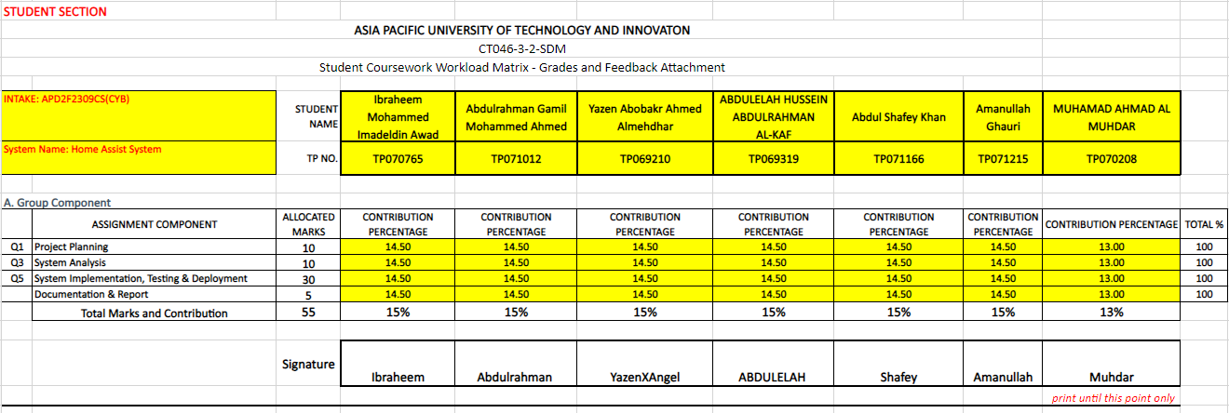

# REFERENCES

(n.d.).

Brush, K. (2019). *compatibility test.* https://www.techtarget.com/whatis/definition/compatibility-test.

devraj. (2022, April 9). *Software Development and Software Testing* . Retrieved from programsbuzz: https://www.programsbuzz.com/article/software-development-and-software-testing

Guthrie, G. (2022, March 10). *A simple guide to drawing your first state diagram (with examples)* . Retrieved from nulab: https://nulab.com/learn/software-development/a-simple-guide-to-drawing-your-first-state-diagram-with-examples/

Hanna Augustsson I, K. C. (2019, September 14). *Re-energising the way we manage change in healthcare: the case for soft systems methodology and its application to evidence-based practice*. Retrieved from BMC Health Services Research: https://bmchealthservres.biomedcentral.com/articles/10.1186/s12913-019-4508-0#citeas

*https://www.knowcomputing.com/what-are-system-changeover-strategies/*. (2021, March 18). Retrieved from Knowcomputing: https://www.universalcpareview.com/ask-joey/what-are-the-different-types-of-approaches-to-implement-a-new-system/

indeed. (2023, February 4). *Soft Systems Methodology: Definition, Steps and Benefits*. Retrieved from indeed: https://www.indeed.com/career-advice/career-development/soft-systems-methodology

Kumar, D. (2023, May 9). *Software Engineering | SDLC V-Model* . Retrieved from geeksforgeeks: https://www.geeksforgeeks.org/software-engineering-sdlc-v-model/

Lowell, K. R. (2023). *Leading modern technology teams in complex times.* Retrieved from Springer nature.

Mulder, P. (2022, March 4). *Soft Systems Methodology (SSM)* . Retrieved from toolshero: https://www.toolshero.com/problem-solving/soft-systems-methodology-ssm/

Nair, U. (2015). Soft systems methodology for personalized learning environment. 35-53.

Nair, U. (2015). Soft systems methodology for personalized learning environment. 35-53.

Oppermann, A. (2023). *What Is the V-Model in Software Development?* https://builtin.com/software-engineering-perspectives/v-model.

P, K. (2023, October 8). *What is Scrum?21- Hygger.io Guides3*. Retrieved from Hygger.io.

Popiolek, D. (2019, May 12). *Agility : Principle PRINCIPLE 5 : BUILD PROJECTS AROUND MOTIVATED INDIVIDUALS.* Retrieved from in-imago: https://www.in-imago.com/en/inimagobooks/agility-principle/principle-5-build-projects-around-motivated-individuals/

testsigma. (n.d.). *Acceptance Testing | What, Why, Types & How to Do?* https://testsigma.com/guides/acceptance-testing/.

Wesbey, O. (2023). *sequence diagram.* https://www.techtarget.com/searchsoftwarequality/definition/sequence-diagram.

*What Are the 12 Principles of Agile Project Management?* (2023). Retrieved from businessmap: https://businessmap.io/agile/project-management/principles

*What is a Data Flow Diagram*. (2023). Retrieved from Lucidchart: https://www.lucidchart.com/pages/data-flow-diagram

*What Is Extreme Programming (XP)?* (2017, June 14). Retrieved from nimble: https://www.nimblework.com/agile/extreme-programming-xp/

Universal CPA Review. (2021, March 18). *What are the different types of approaches to implement a new system? - Universal CPA Review*. https://www.universalcpareview.com/ask-joey/what-are-the-different-types-of-approaches-to-implement-a-new-system/

Tools4ever. (2023, February 4). *What is Phased Implementation? - Tools4ever*. https://www.tools4ever.com/glossary/what-is-phased-implementation/

Knowcomputing. (2023, November 12). What are system changeover strategies? - Know Computing. *Know Computing*. https://www.knowcomputing.com/what-are-system-changeover-strategies/

WaveMaker. (2023, July 21). *Rapid Application Development Model - WaveMaker RAD Model*. https://www.wavemaker.com/rapid-application-development-model/

Chien, C. (2020, February 4). *What is Rapid Application Development (RAD)?* Codebots. https://codebots.com/app-development/what-is-rapid-application-development-rad

Contributor, P. (2022, August 24). Benefits of SWOT analysis. *PESTLE Analysis*. https://pestleanalysis.com/benefits-of-swot-analysis/

SWOT analysis. (2023). *Understanding Your Business, Informing Your Strategy*. https://www.mindtools.com/amtbj63/swot-analysis

Auliyaa, T. N. (2021, February 10). *Project Implementation – closure*. School of Information Systems. https://sis.binus.ac.id/2021/02/10/project-implementation-closure/

*5 Rapid Application Development Phases | Microsoft Power Apps*. (n.d.). https://powerapps.microsoft.com/en-us/rapid-application-development-phases/

Dam, R. F. (2022). The 5 Stages in the Design Thinking Process. The Interaction Design Foundation. https://www.interaction-design.org/literature/article/5-stages-in-the-design-thinking-process#:~:text=Design%20thinking%20is%20an%20iterative

Visual Paradigm. (2019). What is Activity Diagram? Visual-Paradigm.com. https://www.visual-paradigm.com/guide/uml-unified-modeling-language/what-is-activity-diagram/